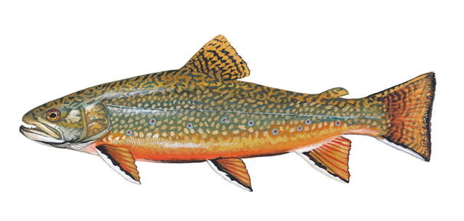 **TROUT**

**IN THE**

**Classroom**

**HOW TO RAISE TROUT IN**

**THE CLASSROOM**

**Ninth Edition (with special COVID-19 Appendix)**

**(Adapted for Vermont’s TIC program)**

**Originally produced by**

**Trout Unlimited Mid-Atlantic Council © 2017**

**Edited by Chuck Dinkel**

**With changes made by the Vermont TIC support team**

## DEDICATION

This manual is dedicated to Jim Greene and Ros Bass. As a member of Potomac-Patuxent Chapter of Trout Unlimited (PPCTU) in 2004 Jim’s vision and leadership resulted in three schools in Montgomery County becoming the first in the state to participate in Trout in the Classroom (TIC). From this small beginning, the program has expanded to over 90 schools and environmental centers state –wide, today encompassing 12 counties and the District of Columbia. Since its inception Jim has tirelessly shepherded and guided its growth and direction. Serving as a role model for protecting our watersheds and streams Jim has influenced thousands of students to become more enlightened stewards of the environment. Jim continues to work and excel at assisting volunteers to fulfill TIC’s mission. In 2013, at TU’s annual meeting, Jim was the recipient of the prestigious TU Youth Education Leadership Award in recognition of his TIC accomplishments.

Over the years Ros has guided the writing and production of this manual. It is she who asks the questions that insightfully ensures the accuracy, conciseness and readability of the document. If there is anything in the manual that Ros does not understand completely odds are teachers will also struggle with it. If the writing passes the “Ros Test” it’s ready for the printer. In addition, her grant writing skills were instrumental to the early success and growth of the Maryland TIC program.

Everyone who has participated in or supported TIC in a volunteer role owes a debt of gratitude to these two hardworking and conscientious individuals.

## INTRODUCTION

This is the ninth edition of***How to Raise Trout in Maryland and D.C. Classrooms.***It updates previous versions by incorporating the additional knowledge gained from experience and new technology during the past three years.[1]

We are grateful for the efforts and dedication of TIC teachers in realizing those objectives. They teach our young people to be mindful of cold water conservation and thereby implement the TIC mission!

This teacher’s manual is intended to facilitate the work of those fine teachers as well as volunteers. We hope you find it useful.

## TABLE OF CONTENTS

Table of Contents

**DEDICATION 3**

**INTRODUCTION 5**

**TABLE OF CONTENTS 7**

**Chapter 1 Principles, Policies, and Practices 9**

**Chapter 2 Equipment for Trout in the Classroom 13**

**Chapter 3 System Set-up 15**

**Chapter 4 Pre-cycling the Tank and Preparing for the Eggs 19**

**Chapter 5 Development Stages of Trout 23**

**Chapter 6 Caring for the Tank 25**

**Chapter 7 Water Testing 31**

**Chapter 8 Feeding the Trout Routinely and During Vacations 35**

**Chapter 9 Releasing the Trout 37**

**Chapter 10 End-of-Year Clean-up 43**

**Chapter 11 Potential TIC Funding Sources 47**

**Chapter 12 FAQ 51**

**Appendix A Start-up and Replacement Equipment Lists 59**

**Appendix B Stages of Trout Growth 61**

**Appendix C Sample Trout Inspection Records 65**

**Appendix D Instructions for Annual TIC Tank Set-up 67**

**Appendix E Directions for Solutions Added to TIC Tanks 75**

**Appendix F How to Modify the Breeder Basket 79**

**Appendix G First Feed 83**

**Appendix H Predicting/Determining When Swim-up Occurs 85**

**Appendix I COVID-19 Special Instructions 89**

**Appendix J VTTIC Contact Information 95**

**Chapter 1 Principles, Policies, and Practices**

**I. BACKGROUND AND MISSION**

The Vermont Trout in the Classroom (VTTIC) program is a voluntary effort primarily supported by the State Council of Trout Unlimited (VTU) and its five regional chapters. TIC is part of a national network of over 4,000 programs in more than 30 states. About a third of these TIC programs are associated with Trout Unlimited (TU). Alternatively, in many states the fish and wildlife department or its equivalent is the principal support for schools engaging in Trout in the Classroom. TIC began around 40 years ago in California. It expanded to other states and was introduced into New York City schools in 1995. Gradually, teachers in many other states with trout habitat, having heard about this powerful environmental education curriculum, began to initiate the program in their classrooms.

As recently as 2012, only five Vermont schools were doing TIC.[2] The following year, VTU agreed to sponsor the program and created a statewide “lead facilitator” role—AKA state coordinator—as well as “chapter liaison” roles—AKA regional TIC coordinators. Since then, Vermont’s program has grown rapidly, often exponentially, with approximately 100 schools participating in 2019-2020 and a geographic range that covers the state: Pownal to Newport, Highgate to Brattleboro. This growth in VTTIC has been accompanied by the development of principles, policies, and practices that help to provide uniform guidance to this expanding program.

Central to VTTIC’s vision and purpose is promoting environmental literacy in our state’s youth. Through TIC, teachers can strive to develop a lifelong conservation ethic among the students on whom the future quality of our water and other natural resources depends.

**THE VTTIC MISSION** is to introduce students to cold water conservation as the first step in becoming future protectors of and advocates for clean and healthy streams, lakes, and rivers. TICis a cold water conservation program taught to students in a classroom and, where it is possible, also through fieldwork. Students are provided with fertilized brook trout eggs that they raise in a 55-gallon tank, in water kept at optimum conditions for the eggs to hatch and grow to fingerling size.

The TIC program concludes with a release of these fish into a local stream. Here, the connection is made between the tank water that has been carefully controlled with respect to temperature, chemical balance, and cleanliness and the stream receiving the trout. The students see that they have created in the classroom a microcosm of what prevails in nature.

**II. PRINCIPLES**

1. The VTTIC program is teacher-driven. Teachers apply to join the VTTIC family.
2. Teachers are responsible for implementing TIC’s mission of introducing students to cold water conservation.
3. Under teacher supervision, students are responsible for carrying out all TIC trout-raising activities.
4. Schools provide administrative support to the program as well as financial support for the annual cost of replacement supplies, currently approximately $100.
5. VTTIC supports the TIC program with training and technical advice and assistance, based on its available regional volunteer resources,.
6. Volunteers play an essential role in helping implement TIC. Because of its mission, VTTIC is eager to partner with like-minded organizations that promote conservation in order to implement and enrich the TIC program for students.
7. Release Day, an annual field trip during school hours, is an integral part of the TIC program.

**III. POLICIES**

**1. ADMISSION TO THE PROGRAM**

Teacher-initiated applications will get priority consideration for admission to VTTIC. Experience has shown that TIC school performance and teacher commitment are better when teachers, rather than school administrators, initiate application for admission to the program. Also, fish survival rates are better. TIC and its curricula are designed for third grade and above. This factor too is taken into consideration when determining admission to the program.

**2. TEACHER TRAINING**

All first-year TIC teachers must attend a free one-day special workshop where they receive TIC orientation, training, and resource materials. Teachers are encouraged to invite their community partners to join them at the workshop. Experienced teachers, too, are urged to attend the workshop. They can learn about recommendations regarding improved procedures, and it is invaluable for new teachers to hear what experienced colleagues have done with the program.

**3**. **EQUIPMENT OWNERSHIP**

VTTIC schools must acquire the equipment and supplies listed in Appendix A of the teacher’s manual. Schools that purchase equipment with their funds own that equipment. When equipment is purchased by or through VTU or one of its chapters, VTU or the chapter retains control of TIC equipment and will reassign it should a school decide to discontinue the program. Schools are responsible for the maintenance, repair, and replacement of their equipment. Schools must also budget an annual amount, currently approximately $100, for the purchase of replacement supplies.

**4. RELEASE EVENT**

A yearly event to release the trout grown in the classroom is a critical part of every VTTIC program. The release event provides closure to the annual school TIC effort and illustrates the relationship between the environment of the tank and that of the stream. Just as the water in the tank needs to be kept clean, chemically balanced, and free of pollution, so should our streams, rivers, and lakes be equally protected.

**5. NETWORKING**

Early in the development of the program, it became clear that VTTIC must network with other organizations to fulfill its mission and help schools enrich their TIC programs. VTTIC has reached out to Trout Unlimited (TU) chapters for volunteers to: (a) deliver trout eggs and food to schools, (b) conduct macro-invertebrate and other stream studies, and (c) teach casting and fly tying. Other organizations with an outdoor orientation, whether national or regional in focus, can also contribute great support to TIC schools and their students.

**6. PROGRAM GROWTH**

The VTTIC program has expanded considerably faster than the required increase in volunteers to service it. To avoid mismatches between volunteers and the needs of the program, VTTIC has adopted a policy of limiting the number of new schools, when necessary, to those for which adequate volunteer support is available. The decision on the number of new schools will be made yearly.

**IV. PRACTICES**

**A. STUDENT ROLE**

It is desirable for as many students as possible to carry out all trout-raising activities, including water quality testing and maintenance, trout feeding, tank maintenance, and year-end equipment cleanup as specified in the teacher’s manual. All of these activities should be done under teacher supervision. It is hoped that students taking an active role in the care of the fish and their environment are more likely to feel more caring and responsible for trout, not only in the tank but in nature.

Each school is expected to maintain an up-to-date record of conditions in the tank, including water chemistry numbers, and fish health, as specified in the teacher’s manual. Often the best way to do that is: (a) for the teacher to designate and train a small team of responsible students to perform regular data entry, (b) for that student team to solicit water chemistry numbers each day from the classmate(s) assigned to do the testing that day, (c) for at least one member of the team to enter the relevant data into an Excel spreadsheet or a Google Sheets document, and (d) for the teacher to periodically review the work of the team.

**B. TEACHER ROLE**

The VTTIC teacher

1. Takes the initiative to apply to join VTTIC and implement the program in that school.
2. Obtains start-up equipment and supplies as listed in the current TIC teacher’s manual.
3. Sets up TIC equipment as indicated in Appendix D. Where possible, VTTIC will endeavor to recruit a TU volunteer to assist teachers doing TIC set-up for the first time.
4. Using the manual, instructs and supervises students in the protocols for proper tank, fertilized egg, and fish care.
5. Oversees students as they maintain careful data records related to (a) the swim-up stage and (b) water chemistry, trout mortality, and trout behavior generally.
6. Plans, organizes, and carries out an annual field trip during school hours to release the school’s trout fingerlings into a local stream. Those teachers with two or more years of experience will recruit the volunteers required for their planned release activities. VTTIC will try to provide volunteers to help first- and second-year teachers implement their trout release events.
7. Assisted by students, cleans up the tank and its accessories as specified in Chapter 10 of the current teacher’s manual.

**C. VTTIC** **ROLE**

VTTIC management will supply each participating TIC facility with free fertilized brook trout eggs[3] and enough food to promote healthy trout growth while the hatchlings are in the school tanks.

Each fall, VTTIC will send the Vermont Department of Fish and Wildlife a list that includes contact information of all schools wanting to raise trout in classrooms. Following the Release Day season, VTTIC will send an updated list that includes the names of streams into which schools released their fish.

Each fall, VTTIC will organize a training workshop for TIC teachers and volunteers and will seek funding that will allow the workshop to be provided free to participants.

VTTIC is also responsible for developing, updating, and distributing the teacher’s manual as well as online materials. The manual is the key compilation of best practices and procedures for successful implementation of the VTTIC program.

**D. VOLUNTEER ROLE**

Volunteers are an essential part of the VTTIC family. They may come from both within and outside the school community and can often be TU members. Volunteers may deliver fertilized eggs and food to VTTIC schools and may contribute in other ways, including: (a) helping teachers resolve problems of tank management, (b) checking on tanks over school breaks or when the teacher is away, (c) sharing trout-related skills like fly tying and fly casting, (d) assisting teachers and students at release events, and (e) speaking to students on topics such as the importance of the health of our streams, rivers, and lakes to our future; how streams provide the temperature, chemical balance, and cleanliness the students maintain in the tank for trout survival; and other topics relevant to the program.

## Chapter 2 Equipment for Trout in the Classroom

Appendix A contains the list of equipment required to set up and maintain the Vermont Trout in the Classroom program. The first items listed can be purchased online or over the phone from ThatPetPlace (contact information below). For those engaging in the pre-cycling process, ammonium chloride can be purchased through Amazon.com. The recommended source for the aquarium chiller is TradeWind Chillers. Their contact information is provided as well. The 55-gallon tank can be purchased at a substantial discount several times a year at PETCO. The final items (Rows 39 through 45) can be obtained from a local hardware or home improvement store.

**For information about ordering from ThatPetPlace.com** contact:

Stephanie Welsh

Senior Business Account Representative

ThatFishPlace/ThatPetPlace

237 Centerville Road

Lancaster, PA 17603

Phone: 717-299-5691, x1288

Local Fax: 800-786-3829

Direct Fax: 717-381-2266

e-mail: stephanie.welsh@thatpetplace.com

The VTTIC program uses the DI-25 ¼ HP TradeWind drop-in chiller. This chiller is designed for 100-125 gallon tanks, thus providing a desirable safety margin for the smaller sized tanks used by the VTTIC program. TIC’s preference for the TradeWind drop-in chiller is based on:

* satisfactory experience;
* convenience (less maintenance, no water pump needed);
* a 5-year warranty; and.
* availability of spare units and parts

To order the chiller contact:

TradeWinds Chillers

510 Corporate Drive, Suite F

Escondido, CA. 92029

760-233-8888

Hal Collier; President

## Chapter 3 System Set-up

***REFER TO APPENDIX D FOR DETAILED PICTURES OF SYSTEM SET-UP***

1. **PREPARING THE TANK**
2. The best location is close to an electrical outlet and a sink to make it easier to fill and drain the tank. Select the location for the tank carefully because once it is filled with water, it won’t be moveable. If possible, avoid positioning the tank under fluorescent lighting. If the tank must be placed under a fluorescent light fixture, either keep that unit/those units switched off or ask your school custodian to remove the bulbs from the fixture(s). Do not use aquarium lights.
3. The tank should be away from direct sunlight. Sunlight will raise the water temperature in the tank and promote the growth of algae. This will put a strain on the chiller and require additional tank cleanings.
4. Place the tank on a stable lab-type counter[4], bench, or stand capable of supporting a total of 600 pounds (the tank, 55 gallons of water, and gravel). If no such furniture is available or can be built, consider using three stacks of cinder blocks with an 18” X 48” piece of ½” plywood across the top of the stacks.
5. **Before filling the tank**, place a closed-cell polyethylene insulation board under the tank that has been cut to fit the bottom of the tank.
6. Newly hatched trout prefer relative darkness, hiding from predators in the cover provided by stream structures. To recreate this dark environment, use Velcro or duct tape to attach polyethylene insulation boards that have been cut to fit the top, front, back, and sides of the tank. The top and back insulation should also have cut-outs to accommodate the filter and the chiller coil hose. In addition to providing the desired darkness, the polyethylene boards will also insulate the tank, thus reducing chiller operating time and prolonging its life. Keep the tank covered on all sides by its insulation during their first six weeks of hatchling development (one week hatching, 3 weeks absorbing the egg sac, and 2 additional weeks or more in the breeder basket while they learn to swim up and feed). The foam insulation can be removed (as briefly as possible) for inspecting the eggs/alevin and for performing tank maintenance.

**B.  GRAVEL**

1. The items from ThatPetPlace for the first-year set-up include two bags of gravel (“Shallow Creek Pebbles”). The gravel provides a large surface area on which bacteria can grow and provides about 20% of the tanks bio-filtering.
2. Gravel should be rinsed before being placed in the tank. A bucket or a colander is useful for this purpose. After getting the gravel as clean as possible, distribute it evenly across two-thirds or three-quarters of the bottom of the tank, leaving the remainder of the tank bottom completely clear of gravel. The gravel-free area permits students to see when the build-up of trout and food waste has reached the point when it is desirable to siphon the tank bottom.

**C. CHILLER SET-UP**

Save the chiller shipping carton; it can be used if the unit needs to be returned to the manufacturer. Send the TIC coordinator an email with the name of the school, purchase date of the chiller, and its serial number (located on the instruction sheet). To promote uniform water temperature in the tank, the following tank configuration is suggested:

1. Place the chiller housing on the left side of the tank. On the left side of the tank also install and submerge the chiller coil. Never run the chiller unless the coil is fully submerged.
2. Make sure that nothing obstructs air from entering and exiting the chiller housing. Do not place the housing in an enclosed area under a tank stand. Lack of fresh air will cause the unit to overheat and malfunction.
3. Install the temperature sensor that is attached to the chiller on the right side of the tank. (Chillers manufactured prior to 2014 have a plastic tube into which the temperature sensor is inserted and sealed with black cork sealant. A suction cup holds the tube in place. Beginning in 2014 the temperature sensor is sealed with a waterproof marine-grade shrink tubing eliminating the need for a plastic tube.)
4. The configuration above, with the coil and the temperature sensor at opposite ends of the tank, promotes uniform water temperature throughout the tank.
5. Periodically, check the cooling fins of the chiller for dust. Make sure the unit is positioned so that you can see and remove any dust that accumulates on the chiller fins.
6. Follow the manufacturer’s instructions for programming the chiller’s controller unit. It must be set for degrees F (Fahrenheit) and in the Cooling mode. Set the chiller for a temperature differential of 2° F.
7. Firmly connect the controller to the chiller unit. A loose connection will cause the chiller to run continually. **Don’t plug the chiller, a power strip, or any other electrical component into a Ground Fault Interrupter (GFI) circuit** that needs to be reset following a power outage. Loss of power over a weekend or holiday will result in fish kills unless the GFI circuit is promptly reset.

**D. AIR PUMP CONNECTION**

1. Place the air pump on top of the chiller housing.
2. Place the air stone on the bottom of the tank directly under the chiller coil. Since the air stone is quite fragile, handle it with care when you unpack and install it. Do not place it under the breeder basket or the intake to the filter. Many teachers attach the air stone to a flat rock with “zip-ties” to keep it from floating up.
3. Measure the tubing and cut a length that reaches from the air pump to the air stone. Cut the tubing near the pump and insert the check valve. Make sure the check valve faces the proper direction to prevent water from returning to the air pump in case of a power outage. (The OUT side faces the air pump; the IN side faces the air stone). The arrow on the Fusion check valve should point in the direction of the air stone.
4. Connect the tubing from the air pump to the check valve and then to the air stone. Greasing or lubricating the fittings on the air pump and check valve with Vaseline or saliva will make it easier to install the tubing.
5. Fill the tank with tap water. **Treat the water with NovAqua Plus** at this time to remove chlorine and heavy metals.
6. Wait 30 minutes before plugging in the air pump to saturate the air stone fully and provide an even air flow. Gravel placed around the frame of the air stone will help keep it in place.

**E. THE AQUACLEAR 110 WATER FILTER**

1. Install the AquaClear water filter following instructions supplied with the unit.
2. Mount the filter on the left side of the tank back so it that it directs water toward the chiller coil to prevent it from icing up.
3. **Cover the mouth of the intake tube with netting or nylon screening to keep fry from being sucked into the filter.** Nylon screening, fastened tightly to the tube with a plastic tie, works well. Do not use fine-mesh material such as cheesecloth or nylon stocking; they can block the water flow through the filter and prohibit debris from entering the filter, which is a necessary part of the filtering process. Here’s an example of screening that should work just fine:

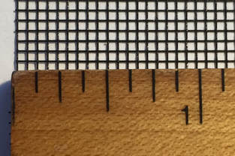

**F. BREEDER BASKETS**

1. The breeder baskets are designed to hold your eggs and your alevin until they are strong and competent feeders and capable of handling the “big, wide world” of a 55-gallon tank. The plastic frame should be securely assembled. Because the frame can come apart fairly easily, many teachers apply a dab of aquarium cement at the corner joints.
2. The netting provided with the breeder basket is too fine and will prevent waste and excess food from falling through the netting. This accumulation of waste will create an unsanitary environment that can pose a serious risk to trout health. For this reason, you should replace the bottom netting (see Appendix F for illustrated directions). To do so, follow these procedures:
3. Buy a tube of aquarium-safe silicone cement.
4. Cut a piece of nylon screen into a 4.5” X 6.5” rectangle.
5. With the seams on the outside, spread the bottom panel of the netting on a flat surface protected by aluminum foil.
6. Apply a bead of silicone cement evenly to the bottom netting just inside the seam.
7. Place the rectangle of nylon screening on top of the bottom netting panel and press down on the edges to secure the screening to the cement.
8. Allow the cement to dry thoroughly.
9. Once the cement is dry, use fine-pointed scissors to cut the fine netting away.
10. To protect hatchlings from getting caught between the netting and frame, place the net **inside** the frame and secure it at each corner with fine wire or needle and thread.
11. At least five days before the eggs arrive, install the breeder basket on the front wall of the tank. It should be placed at the opposite end of the tank from the filter outflow.

**G. DIGITAL THERMOMETER**

Before installing the digital thermometer, remove the protective film that keeps the battery from making contact with the thermometer terminals. Turn unit ON and check operation. Turn unit OFF and remove battery (until the eggs arrive) to extend its life during storage.

**YOUR SYSTEM IS NOW OPERATIONAL!**

**H. FOAM INSULATION**

Once you’ve finished assembling your system, you need to wrap the tank in panels cut from the foam insulation board(s) you purchased. It is important to completely cover all six sides of your tank with insulating foam board for three reasons: first, trout can’t be exposed to light during the egg and early alevin stages; light exposure for more than a brief period could kill the trout at these fragile stages. Second, wrapping your tank in foam will greatly reduce the cost of electricity required to cool your water. Finally, without insulating covering, the glass of the tank will be constantly fogged by condensation.

If you have your students calculate the combined area of sheets of foam needed to cover all six sides (including necessary overlaps), they will discover that that total is less than the total area of one 4’ X 8’ sheet of foam. Therefore, it should be possible to completely wrap your tank with a single sheet, right? Well, while it is possible, it’s not simple. Fortunately, Bob Wible, TIC Liaison for Central Vermont TU, has developed a plan that allows you to completely surround the tank on all six sides with a single 4’ X 8’ sheet of insulating foam. You can find Bob’s plan, a document called “Insulation Diagram,” in the Google Docs collection.

**REMINDER!**

## Treat all water with NovAqua Plus to remove chlorine and heavy metals.

## Chapter 4 Pre-cycling the Tank and Preparing for the Eggs

**Pre-cycling introduction**

We highly recommend that teachers “pre-cycle” their tanks. Pre-cycling is a process designed to put your tank through the nitrogen cycle (see page 32) *before* the arrival of your eggs. When this works, it establishes a colony of good bacteria in your filter that can (a) convert ammonia (from fish waste and decomposing excess food) to nitrite and (b) convert nitrite to the less harmful nitrate.

Pre-cycling has worked extremely well for many teachers who tried it. For reasons we can’t fully explain, however, some teachers who precycled found that they still had high nitrogen levels close to the date when eggs were going to be delivered[5]. As a result of these mixed outcomes, not all regional coordinators are committed to precycling in all cases. If you’re trying to make a decision about precycling, check with your regional coordinator.

**INSTRUCTIONS FOR TEACHERS WHO PLAN TO PRE-CYCLE**

An important note about pre-cycling, and biology in general. We have done our best to provide a standard protocol for pre-cycling below, however, each tank set up is ultimately unique. There are many variables we cannot control such as your classroom temperature, water quality, sources of bacteria, etc. For the protocol below to be successful, water quality monitoring is critical and you may (likely will) need to adjust the protocol based on those readings. In other words, this is an active, living protocol, not a “dump and walk away” protocol ☺.

1. **START THE PRE-CYCLE PROCESS ON THE FIRST MONDAY OF DECEMBER.**

* Your tank water should be at room temperature when you precycle. “Room temperature” is not 65 or 67 degrees, even though that’s what many of our rooms are these days. Precycling would proceed much better if the tank water was 75 degrees. At this warmer temperature, optimal growth of the bacteria that drive the nitrogen cycle occurs. The colder the water, the more limited growth of the beneficial nitrogen-cycling bacteria. That’s why we strongly recommend using an aquarium heater to maintain your tank at that temperature. We have included one (cost $25) in the ThatPetPlace kits in Appendix A. One on-line article on “How to choose the right aquarium heater” recommends that, if you have a 55-gallon tank, you get at least a 300-watt heater if you’ll need to raise water temperature ten degrees (or two 150-watt heaters) and a 400-watt heater (or two 200-watt heaters) if you need to raise temperature more than ten degrees. Google [the article](https://www.fishlaboratory.com/fish/aquarium-heater/) if your tank is significantly smaller or larger than 55 gallons.
* Run your filter 24-7 during this time.
* DO NOT run the chiller.

**Day 1:**

* Test the water chemistry of your tank—pH, ammonia, nitrite, nitrate—and record the values you get. It is **unlikely** that you will have any readings for ammonia, nitrite, and nitrate at this point, but it is nonetheless important to check. (High readings could indicate a problem with your water source that needs to be addressed before moving forward.)
* For proper pre-cycling, the pH of the tank needs to stay above 7.0. The pH will potentially drop when the bacteria convert ammonia to nitrite. A pH below 7.0 is a primary cause of pre-cycling failure.
* Following water testing, add the appropriate amount of Ammonium Chloride Solution to the tank based on your tank volume. Using Dr. Tim’s Ammonium Chloride Solution, you would add 4 drops per gallon of water (read the bottle for instructions). For a 55-gallon tank, adding *two teaspoons* of Dr. Tim’s Ammonium Chloride Solution should introduce approximately the right amount of ammonium chloride. But this is critically important to test and adjust if needed. Add the Dr. Tim’s and measure ammonia levels. You need to get above 1 ppm but below 5 ppm to start the cycling process. If you are below, add more Dr. Tim’s and adjust accordingly. If you go over, remove water from the tank and add fresh water.
* Take 5-in-1 test strip readings and an ammonia measurement **after** adding the ammonium chloride solution. Make sure you get a pH reading between 7.0 and 8.5 and an ammonia reading above 1 ppm but DO NOT allow ammonia to exceed 5 ppm; this will kill the bacteria before they have a chance to grow.
* Add the appropriate amount of Nite-Out II bacteria solution per the instructions on the bottle for your tank size.

**Day 2:**

* Measure and record 5-in-1 test strip and ammonia readings.
* If pH drops below 7.0, perform a 25% water change with treated water to bring pH back above 7.0. If KH is below 150 ppm, add baking soda to raise it. (See Appendix E of this Manual.)

**Day 3:**

* Measure and record 5-in-1 test strip and ammonia readings.
* **If** ammonia **and** nitrite readings are *below* 3 ppm, add more Dr. Tim’s Ammonium Chloride Solution (same as Day 1). If readings are *above* 3 ppm, do nothing.
* If pH drops below 7.0, perform a 25% water change with fresh water to bring pH back above 7.0. If KH is below 150 ppm, add baking soda to raise it.

**Day 4 & 5:**

* Measure and record 5-in-1 test strip and ammonia readings.

**Day 6:**

* Measure and record 5-in-1 test strip and ammonia readings.
* **If** ammonia and nitrite readings are *below* 3 ppm, add more Dr. Tim’s Ammonium Chloride Solution (same as Day 1). If readings are *above* 3 ppm, do nothing.
* If pH drops below 7.0, perform a 25% water change with fresh water to bring pH back above 7.0.

**Days 7 & 8:**

* Measure and record 5-in-1 test strip and ammonia readings. Many tanks are cycled at this point if conditions have been optimal. After you have observed spikes in both ammonia and nitrite levels and nitrate showing up, your tank is close to being cycled!
  1. If your tank is cycled, **BOTH** ammonia and nitrite will be *below* 0.5 ppm and some nitrate will be around.
  2. However, if at this point you still have high ammonia or nitrite levels:
     1. Add a 2nd dose of Nite-Out II per instructions on the bottle.
     2. Double check pH and water temperature. Make sure pH is above 7.0 and that water temperature is above 70 degrees Fahrenheit.
* Proceed to “Until Eggs Arrive” (below).

**Until Eggs Arrive:**

You need to feed the bacteria you’ve now established in your tank.

* Add a small pinch of fish food *every other day\** and
* Once a week measure and record 5-in-1 test strip and ammonia readings.
* *Alternative to fish food, you may feed the bacteria by adding more Dr. Tim’s following the schedule you used for cycling. A well cycled tank will consume the ammonium added rapidly.

**When you’re adding fish food and the ammonia and nitrite stay below ~1 ppm, you know you have a cycled fish tank ready for fish!**

**Additional Notes:**

* IMPORTANT - **Never let ammonia OR nitrite get above 5 ppm.[6]**
* If either ammonia or nitrite concentration gets above 5 ppm, immediately do water changes to lower the concentration. Add fresh Nite-Out II after the water change to re-kick-start the cycle.
* Do not let the pH drop below 7. If it does, do a partial water change (25% or more, as needed) to bring the pH back above 7.0.
* Having tank water temps above 70°F is important for rapid precycling. If your tank temp is lower, the process will take much longer.

**B. FIVE DAYS BEFORE EGG DELIVERY**

1. Turn on the chiller, setting the temperature to the temperature of the hatchery water. (You’ll receive an e-mail informing you what that temperature is.)
2. Test the water for pH, ammonia, nitrite, nitrate, and carbonate hardness (KH). The pH of the tank should be stable within a range of 7.0 - 7.6 for optimum biological processes.
3. Make sure the KH (carbonate hardness) of your tank’s water is 150 or more. Refer to Chapter 7 for guidance regarding KH and to Appendix E for instructions on how to use baking soda to correct low KH.

**C.** **ONE DAY BEFORE EGG DELIVERY**

1. Using the digital thermometer, check to see that the water temperature is at the desired level.
2. Place the air stone near but not underneath the breeder basket.
3. Check the breeder basket. Make sure that water flowing from the filter and bubbles flowing from the aerator will not disturb the resting eggs. If necessary, redirect one or both of these flows or reposition the basket.

**D. EGG DELIVERY PROTOCOL**

1. Be sure the filter is operating at its highest flow rate.
2. Eggs will arrive in a container of hatchery water at a temperature approximately the same as your tank. (The eggs will be transported from the state hatchery in coolers to keep the temperature as stable as possible.)
3. When the eggs arrive, place the closed container in the tank and allow it to float on the surface of the water for 20 or 30 minutes. This will gradually sync the temperature of the water in the container with your tank’s temperature.
4. Gently pour the eggs into the breeder basket.
5. Add Nite-Out II to the tank after the eggs are in the basket. See Appendix E for directions for adding bacterial solutions to the tank. (The filter represents 80% of the system’s biological oxidation processes.)

**Chapter 5 Development Stages of Trout**

1. **EMBRYO STAGE**
2. Fertilized trout eggs have black eyes and a central line that show healthy development. All the eggs will hatch over a 5-7 day period from the time the first one hatches. Hatching usually starts within a week of egg arrival.
3. The outer shell of the eggs must remain translucent. Uniform cloudiness can be okay. Some eggs will not hatch properly. Any fully opaque eggs or those with white or opaque spots will not develop and should be removed when seen (inspect them twice a day if possible). A turkey baster works well for that task. The white spots are a fungus that spreads very rapidly. Be sure to check the breeder basket before leaving school on Friday or the last day of the school week.
4. The leftover shells float to the top of the tank or the breeder box. Use the small aquarium net or turkey baster to remove them. Fish enzymes will break down any remaining shells and create foam. This is normal. Scrubbing the sides of the tank will loosen the foam. During this phase, a jelly-like fungal growth may appear. Check for it around the inside tank surfaces. Also check for fungal growth on the surfaces of the breeder box. If you find any, wipe or scrape the surfaces with a clean sponge or brush to loosen and send this growth through the tank filtration system.
5. **ALEVIN STAGE (from hatching to 4-8 weeks, depending on water temperature)**
6. When the embryos hatch, they have large yolk sacs that serve as their food source.
7. Look for any odd-looking trout (two-headed, three-headed, unusual heart development, etc. These odd trout usually don’t survive and illustrate the principle of survival of the fittest.
8. Alevin can survive in a Petri dish for short periods and can be observed closely under a microscope or by using a hand lens.
9. Tank maintenance is simpler when the alevin are in the breeder box. Actually, **the longer the alevin can stay in the breeder basket, the longer these hatchlings have time to learn to swim to the surface to feed.**

**C. SWIM-UP STAGE (AKA “First Feed”) (4-6 weeks)**

The timing of “first-feed” is critical in young trout. Every year the single greatest cause of trout mortality occurs when teachers and their students “miss” the swim-up stage. The signs of swim-up are subtle, and especially teachers new to raising trout may have difficulty noticing them. A further problem is that the swim-up period doesn’t last long, perhaps only three or four days; and, if you don’t know when this is going to take place or happen to be away from your tank when it does, you can miss it entirely.

Initially, alevin will “swim up” to inflate their air bladders—independent of the need for food. It is important to delay first-feed until the majority of fish have only a small slit of yolk visible. Research indicates that fish still have considerable yolk reserves when only a slit is present. Feeding too early is not advantageous to the fish and only creates a fouled tank environment. If you are in doubt, place a small number of fry in a clear glass beaker/jar to examine the ventral surface (belly) from below. Refer to Appendix G for photographs.

Here’s a link to a YouTube video about the swim-up stage that may also be helpful: https://www.youtube.com/watch?v=0VfuBYoeb8g.

1. We have provided a spreadsheet with built-in formulas to help you either *predict* or *control* when swim-up occurs. Appendix H describes how to use this spreadsheet for these two purposes. There are also a few pages on the VTTIC web site (<https://www.vttucouncil.org/?page_id=384>) that explain this procedure and provide access to the digital spreadsheet.
2. As yolk sacs disappear, some trout will start swimming to the top of the tank. The following is advice provided by the Albert Powell Hatchery manager: “It’s my experience that small percentages of fish will begin to swim up continuously over a period of 3-5 days. I begin to supplement feeding when approximately 25% are up and gradually increase feed amount as the percentage increases. When you begin feeding, only spread a minuscule amount of the food near any swimming trout.”
3. When you’re beginning to suspect that the alevin may be ready to swim up, raise the water temperature to 52 to 55 degrees and expose the tank to light for at least half an hour a couple of times a day. See if this stimulates their swim-up behavior.
4. Once all fry are feeding eagerly, **keep them in the breeder basket for at least two more weeks.**
5. Two or three weeks after all the fry have been feeding, reposition the basket so that one side is under the surface of the water. This will allow the more adventurous fry to swim out into the main tank.
6. After the vast majority of fish have left the comforts of the breeder basket, you may unhook the basket and lower it gently to the bottom of the tank.
7. Continue to add Nite-Out II to your tank as often as once a week according to directions in Appendix E.
8. Once all the fish have left the breeder basket, you can remove it from the tank. At this time, you can also remove the front foam insulation during the school day.

**D. FRY STAGE (6-8 weeks)**

Some trout never learn to feed and will die. These non-feeding fish are called “pinheads” (big heads, skinny bodies). These trout should be removed. They will not develop. Most TIC classrooms see a mortality spike due to pinheads. It is quitenormal.

**E. PARR STAGE (the rest of the time until release)**

1. When a fry grows to 2 inches it becomes a fingerling. Larger fingerlings will develop dark vertical stripes known as parr marks that serve as camouflage. At this stage they are called parr.
2. Cannibalism can and does occur. The big fish will eat smaller fish. If cannibalism becomes an issue, feed more often to assuage hunger. Large predatory fish can be separated and given “time out” by placing them back in the breeder basket. See Appendix B for pictures of the developmental stages of trout.

## Chapter 6 Caring for the Tank

**A. TANK CLEANING**

This section applies mainly to tank maintenance **after** the fish leave the breeder basket**.** The most important job after the hatchlings are in place is to keep the tank system clean and the bacteria colonies growing and happy.

1. Whenever possible, do your tank work without putting your hands or those of students into the water.
2. If you need to put hands in the tank, wash hands in **de-chlorinated** water**—**trout are extremely sensitive to chlorine—to remove all contaminants (such as soap and lotion) and dry them thoroughly. Proper hand care when working in the tank will ensure a higher trout survival rate.
3. Remove dead and sick-looking fish from the tank immediately. Some fish may start to get lethargic or have problems swimming. Eventually, they simply float around the tank or sink to the bottom, die, and decay. Even one dead fish, if left too long, can spread disease and endanger the whole population
4. The gravel should be cleaned twice a week (e.g., Tuesday and Friday). Clean half of the gravel each of these days. During one cleaning, use the siphon to suck up fish waste and dirt from the non-gravel portion of the bottom of the tank and half of the graveled part of the tank. (See Chapter 3.B for gravel distribution in the tank.) Gravel is cleaned by moving the siphon through and under the gravel, sucking up water and fish waste trapped in and below the gravel. Use one of the 5-gallon buckets to collect the wastewater. Clean the remaining portion of the gravel in the tank during the next semi-weekly cleaning.
5. Occasionally, fingerlings can get sucked up along with dirt from the gravel. Just net them and return the runaways to the tank. They may look dispirited or even comatose, but the odds are that they will survive.
6. Only remove as much water as needed to clean the gravel and replace that water with water that has been treated with NovAqua Plus water conditioner. (See Appendix E for instructions.) As the fish grow, it may be necessary to increase the frequency of weekly gravel cleanings. Even though about 80% of biological activity takes place in the filter, gravel in the tank serves as part of the tank’s biological filter.
7. Weekly remove the slime and dirt that accumulate on the sides of the tank, using a hand mitt, a long handled brush, or some other suitable implement. As the trout increase in size, bi-weekly cleaning of this sort may be required.
8. Weekly examine the filter intake and remove tank debris, as well as any dead or trapped fingerlings found there.

**B. MAINTAINING CHEMICAL BALANCE IN THE TANK**

Eighty percent or more of the biological activity of the trout tank takes place in the filter. The goal of the pre-cycling process was to “seed” the filter with bacteria that play three different roles (decomposition, nitrification, and denitrification) in maintaining a healthy water chemistry balance for trout. If this is accomplished the need for water changes is minimized. See Appendix E for proper use of additives.

**High ammonia and nitrite levels** indicate a lack of adequate biological nitrification. Nitrification is the biological [oxidation](http://en.wikipedia.org/wiki/Redox) of [ammonia](http://en.wikipedia.org/wiki/Ammonia) or [ammonium](http://en.wikipedia.org/wiki/Ammonium) to [nitrite](http://en.wikipedia.org/wiki/Nitrite) followed by the oxidation of the [nitrite](http://en.wikipedia.org/wiki/Nitrite) to [nitrate](http://en.wikipedia.org/wiki/Nitrate). Check KH and add baking soda if required. Add 20 ml of Nite-Out II **to the filter** to increase ammonia removal. Nitrite and Nitrate are the byproducts of nitrification.Water changes are an additional method of correcting ammonia problems.

Be aware, however, that some short-term spiking of ammonia, nitrite, and nitrate readings is normal. Don’t over-react and increase the size and frequency of water changes **unless an ammonia spike is accompanied by signs of fish distress**. High ammonia and nitrite levels prevent fish from absorbing oxygen through their gills, at which time the gills darken and may take on a brown color. Fish will be seen at the surface gasping for air or swimming erratically. This is the time to take remedial action by adding 20 ml of Nite-Out II and performing a water change.

The ammonia drives the nitrification process of the Nite-Out II bacteria. Because our tanks typically contain more fish than is recommended for a 55-gallon tank, some removal of fish and food waste by vacuuming the tank bottom may still be required.

At the early stages of development, only 2-3 gallon water changes may be necessary. As your fish grow, and food portions increase you may need to change about 5 gallons of tank water at a time. **The bacteria in your tank should provide the first line of defense against changes in your tank that affect water chemistry balance.**  **Water changes are secondary to biological activity**. Allowing the bacteria to do their job will reduce your need for water changes. The log of daily water testing and the overall health of the trout will also help you determine how much water to change and when to do so.

**Note:** The ammonia test produces a value that consists of ammonia plus ammonium. The former is un-ionized (NH3) the latter is ionized (NH4+). Ammonia is hazardous to fish and plants; ammonium is not. The test reading is a measure of the sum of both. However, it does not indicate the percent distribution of each component. Therefore, if the test yields an elevated ammonia reading but the fish show no sign of distress, it is very likely ammonium is the larger component of the reading.  At lower temperatures (520-540F.) and pH between 7.0 – 7.8 the ammonium value predominates. Unless the fish show signs of distress, there is no need to panic if ammonia readings seem on the high side. At pH readings above 7.8, ammonia toxicity increases**.**

**How temperature and pH affect ammonia**

Ammonia varies in toxicity at different pH and temperature of the water. For example, ammonia (NH3) continually changes to ammonium (NH4+) and vice versa, with the relative concentrations of each depending on the water's temperature and pH. At higher temperatures and higher pH, more of the nitrogen is in the toxic ammonia form than at lower pH.

At what point should you get concerned about ammonia levels becoming a threat to your fish given that ammonia is constantly being produced? The answer to this question will depend on the temperature and pH of your tank water, how many fish are in your tank, and how much uneaten fish food remains in the system.

This chart identifies the level of ammonia you can tolerate in your fish tank before it affects the fish. You will notice that at very warm water temperatures a small amount of ammonia can be toxic to your fish. At the opposite end of the spectrum in very cold water, the opposite is true. Fish can tolerate higher levels of ammonia the cooler the water. This is also true for dissolved oxygen. Cold water can store more dissolved oxygen than the same volume of warm water. The good news is that the water temperatures and pH levels at which our trout are raised tend to reduce the effect of harmful ammonia. If you encounter an ammonia spike that is causing fish mortality you may try lowering the water temperature 2-4 degrees to see if the fish start to recover. (Example: 10**°** C = 50**°** F. At pH of 7.6, the ammonia test reading would have to exceed 2.8 ppm (interpolate between 3.2 ppm and 2.4 ppm) before it became significant.)

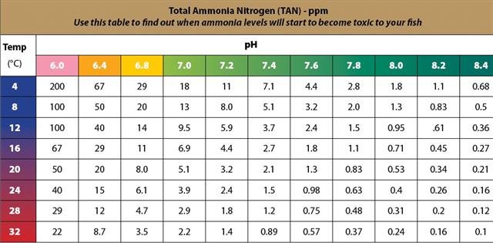

1. Water changes should be performed as needed. The best way to remove water from the tank is by siphoning because this also removes excess waste. In an emergency, an alternative to siphoning is to use a clean gallon jug to scoop water out of the tank. Remember, the jug and the hands of those dipping the jug should be clean and chlorine-free.
2. Fill a clean 5-gallon plastic bucket with tap water equal to half the amount of water to be removed from the tank. Add the appropriate amount of NovAqua Plus water conditioner to de-chlorinate (and remove harmful heavy metals from) the water being added. Then add the remaining half of the water being removed. One ml. treats 2 gallons of water. Slowly add the de-chlorinated water to the tank. When done twice a week, this procedure achieves a weekly routine water change that helps keep trout mortality low.
3. If the fish appear stressed or start dying in large numbers, it is possible your tank is experiencing an ammonia spike due to a lack of adequate nitrification. Check the ammonia level. If high, assure KH levels are correct, and then add 20 ml Nite-Out II to increase biological ammonia removal. Contact your TIC volunteer for assistance. Correcting the problem may require a large water change, but it is best to proceed with this only after receiving advice.
4. Always keep two or more 1- or 2-liter bottles of de-chlorinated water in the freezer to maintain the tank water at 52° F in case of a temperature spike caused by a chiller or power failure. The outer surface of these bottles must be cleaned and then rinsed with de-chlorinated water before freezing.
5. When convenient or necessary, water changing may be combined with tank cleaning. As fish grow and feed rates are increased ammonia production is also increased. Since the nitrification process is critical to fish survival always control essential KH levels and add Nite-Out II when ammonia levels increase.

**C. CHILLER MAINTENANCE**

Once a month, check the chiller intake cooling fins for lint and dust. If necessary, dislodge the dust with a stiff paint brush or tooth brush and use a small hand vacuum to collect the dust. A build-up of dust can cause the compressor to overheat and fail.

**D. CHECK LIST**

**Daily**

1. Check tank temperature. A temperature increase might indicate a chiller problem.
2. Once your fish are feeding, feed the trout (see Chapter 8 for feeding guidelines).
3. Remove dead fish or debris from the tank.
4. Update data records based on recent water testing and observational reports.
5. Ensure that (a) water is flowing from the filter, (b) no fry are caught at the intake points, and (c) the air stone is working properly.
6. Check the filter and the air pump hose connections to ensure there are no leaks.

**Two or three times a week**

1. Test water chemistry (pH, ammonia, nitrites, and nitrates) and record the readings on a Log Sheet (see Tank Inspection Record, Appendix C). Daily testing encourages participation by more students and is optimal from the standpoint of trout health. (In the early stages of the TIC process, especially before your fish have begun to feed, water chemistry *should* be stable. If that’s the case, you can, if you want, reduce the frequency of your water testing regimen.)
2. Clean/siphon gravel as instructed above. Persistently high ammonia or nitrite levels may indicate the need for more frequent or more thorough gravel cleaning.

**Weekly**

1. Conduct the KH test and record the readings in the log. If KH has dropped to 100 or below, use baking soda to raise it. (See Appendix F for instructions on how to use baking soda to correct low KH.)

**F. REPAIR AND REPLACEMENT OF TIC EQUIPMENT**

Regardless of how obtained, each school is responsible for the care, maintenance and replacement of its VTTIC equipment.

1. **Chillers.** TradeWind chillers have a 5-year warranty. The invoice for each school’s chiller should be kept in the school’s VTTIC file in order to determine whether the unit is still under warranty in the event of failure. Save the original box in case the unit needs to be returned to the manufacturer. Send a TIC coordinator an email with the serial number of the unit. It is located on the unit’s instruction sheet. The cost of warranty repair is the cost of shipping the unit to the manufacturer (about $70).

Although the reliability of chillers is high, eventually failures will occur. VTTIC will try to provide a spare unit within 24 hours of a notice of failure if one is available. If the broken unit is no longer under warranty, two options exist. (1) Replace with a new chiller. VTTIC should be notified of this intent. (2) Refurbish the unit. After consulting the manufacturer, VTTIC will recommend whether the unit should be discarded or refurbished. Refurbishing costs vary with the condition of the unit and have ranged between $100-$150 plus shipping. To refurbish a non-warranted unit, the school pays for shipping both ways. Total repair cost, including shipping both ways, would be about $300. If a school decides to replace its unit, VTTIC may offer to take over and pay for refurbishing the broken chiller to use as a spare. In 2018, a new unit cost $625. Some schools have applied for a grant to cover the cost of replacing their chillers.

When a school receives its new/refurbished chiller, any loaned unit should be returned to VTTIC.

**2. Tanks**. Very few failures have been experienced with fish tanks if carefully maintained, handled, and stored. It is difficult to repair a leaking tank. It is best to replace the tank with a new one. Cost is about $130 unless the school can time its purchase to coincide with one of PETCO’s sales. Check with VTTIC to see if any spare tanks are available. Some schools are able to obtain a tank from the PTA/PTO or parents.

Grant money is sometimes available to replace equipment. However, if you wait until a failure occurs it is possible that your grant application would not be acted upon until the next donor funding cycle. Also donors might give higher priority to a grant request from a new VTTIC school than for replacement of existing equipment.

**Chapter 7 Water Testing**

**INTRODUCTION**

Maintaining safe water chemistry levels is critical for trout healthy. Because we recommend that students do all or most of the water testing and maintain data records, water testing also becomes a great learning opportunity as it takes students inside the exciting world of the chemistry that is so important to the wellbeing of our fish.

TIC teachers and their students have to be concerned about six chemical compounds: carbonate hardness (KH), general hardness (GH), pH, ammonia, nitrite, and nitrate.

**ABOUT THE COMPOUNDS WE TEST FOR**

**pH and Carbonate Hardness (KH)**

1. pH is a number reflecting to what extent water in the tank is acidic, alkaline, or neutral. A pH level of 7.0 to 7.6 is desirable. Trout will survive outside this pH range, but high pH increases ammonia toxicity. A lower pH will also cause a slowing down of bacteria reproduction. Below a pH value of 5.5, nitrification ceases. Do not use solutions or additives that are sold to raise or lower pH without consulting a TIC volunteer. These additives mask problems and often result in pH fluctuations that cause fish stress or even mortality.
2. KH or carbonate hardness (sometimes called *alkalinity*) is a measure of carbonate (CO3 2-) and bicarbonate (HCO3-) ion concentrations dissolved in the water. KH levels determine the capacity known as *buffering* to keep the pH stable. KH is essential to the nitrification process. The process requires 7.1 pounds of KH alkalinity for every pound of ammonia removed. If adequate KH is not present, the nitrification process will stop due to the loss of all bacteria and cannot be restarted. KH minerals are present in municipal, well, and bottled spring water. The level of carbonate hardness in tap and bottled water depends on the source of the water and the treatment processes it has undergone. Tank water with a low KH level (50 ppm or less) tends to be acidic and can cause rapid pH shifts if not monitored carefully. **An initial KH reading of 150 and a maintenance reading of 100 is recommended.**

**Ammonia, Nitrite, and Nitrate**

To different degrees, excessively high levels of these three compounds are dangerous for trout. Ammonia and nitrite are, without question, the most dangerous. High nitrate levels are not desirable, but fish can often survive them.

An ammonia level below 1 ppm is recommended. See the Note with specific information regarding the ammonia test in Chapter 6, Section B, “Maintaining Chemical Balance in the Tank.” Ammonia levels in an aquarium are controlled biologically by nitrifying microorganisms. pH and KH levels are critical to the nitrification process, and to ammonia toxicity. Correct KH levels at the first sign of ammonia increase, adjust pH, and add Nite-out II (nitrifying microorganisms) to deal with ammonia issues. **Water changes should be considered a secondary method of correcting ammonia problems.**

A tank has been effectively undergone the pre-cycling process may have no ammonia or nitrite spikes. But if dramatic increases in ammonia are observed, add Nite-Out II to the tank water to biologically reduce ammonia levels. Water changes may also be needed if the ammonia load becomes consistently too high for the biological filtration to handle, i.e*.,* a level of 2 ppm (not including the ammonium component) or higher. This usually occurs when fish are overfed or there are too many fish in the tank. If the problem occurs frequently, the number of water changes may need to be increased or some fish may need to be removed to reduce the daily level of ammonia.

**THE NITROGEN CYCLE**

**If you have engaged in the pre-cycling process, your tank will have fully gone through the nitrogen cycle before you got your eggs.** Otherwise, changes in the water chemistry of your tank should conform to the classic nitrogen cycle described below. (Unfortunately, experience has taught us that not all tanks follow the classic patterns.)

The classic nitrogen cycle looks like this:

* Readings for ammonia, nitrite, and nitrate are all at zero when you add eggs to the tank. They stay low for a period after your eggs have hatched. (Pre-cycled tanks will typically have somewhat elevated nitrate levels when the eggs arrive.)
* In tanks that have not been pre-cycled, when fish start feeding and producing waste, ammonia rises, but nitrite and nitrate stay low.
* Eventually nitrite begins to rise and, with that, ammonia starts to drop.
* Then nitrate begins to rise, and gradually nitrite goes down. At this point, it is said that your tank “has cycled.” That’s an important milestone. From that point forward, it should be possible to control nitrate levels through periodic partial water changes. (In pre-cycled tanks, nitrate should be the only compound that needs to be managed; ammonia and nitrite should remain at or near zero.)

Here’s what the “classic” nitrogen cycle looks like.

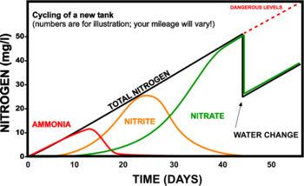

If your tank has cycled in this way either before you get your eggs or after, you and your students should celebrate! If your water chemistry doesn’t follow the hoped for pattern—as many tanks won’t—don’t despair. Every year lots of tanks follow other patterns and nonetheless have successful TIC seasons.

**DIRECTIONS FOR USING TEST STRIP KITS**

1. Two test strip kits are required. One kit is the API 5-in-1 Aquarium Test Strips and tests for acidity (pH), nitrites (NO2), nitrates (NO3), carbonate hardness (KH) and general hardness (GH). The other kit is the API Ammonia Test Strips and tests for ammonia (NH3/NH4).
2. Rather than having students test water in the tank, **have them use the turkey baster to fill a clean beaker** or other clean container with tank water and use this to perform the water tests. This keeps their hands out of the water and prevents residual solutions from getting into the tank.
3. Keep a daily log of test results. This information can help identify causes of fish mortality and also serves as “real” data for students to graph. (And will benefit future TIC practitioners when you submit your data to the state coordinator, who will aggregate them in the spring and study the statewide data for patterns that might reveal ways to improve practice.) The spreadsheet for TIC record keeping can be found in Appendix C.
4. Caution must be taken when handling these kits to keep any moisture from contaminating the unused strips. Make sure fingers and hands are completely dry before opening the kit tubes holding the test strips.
5. Test water three times a week during the pre-cycling process. Then, from the time the eggs arrive until fry start to feed, perform one test a week from each kit. From the start of feeding until release day, perform two tests from each kit every week. However, there may be times when water quality or fish health issues indicate more frequent testing of some of these parameters. For example, if ammonia levels increase, check KH levels at once as KH is essential to the nitrification process. **Don’t forget to chart all your readings**.

**Testing Procedures**

1. API 5-in-1 Aquarium Test Strips (pH, Nitrite, Nitrate, KH, and GH
2. Using the baster, remove some water from the tank and put it into a clean beaker.
3. With dry fingers, open cap of test strip container tube and remove one strip. Close cap tightly.
4. Find color comparison chart on side of container tube.
5. Dip strip into the beaker of tank water.
6. Swirl two times.
7. Remove and hold level with pads facing up.
8. DO NOT SHAKE WATER OFF!
9. Hold strip as indicated on tube side, so alignment of strip pads to comparison chart is correct.
10. Compare to color chart.
11. Immediately read KH and GH.
12. Wait 30 seconds and then read pH, Nitrite, and Nitrate.
13. Document results.
14. Discard test strip.
15. Ammonia Test Strips
16. With dry fingers, open cap of test strip container and remove one strip. Close cap tightly.
17. Find color comparison chart on side of container tube.
18. Dip strip into the beaker of tank water for 5 seconds.
19. Remove and hold strip level with pads up for 60 seconds.
20. DO NOT SHAKE WATER OFF!
21. Hold strip as indicated on tube side, so alignment of strip pads to comparison chart is correct.
22. Compare to color chart.
23. Document results.
24. Discard test strip.

**Chapter 8 Feeding the Trout Routinely and During Vacations**

**A.** **INTRODUCTION**

The routine feeding guidelines below are based on an estimate of 125-145 fish per tank and the kind of measuring spoons used in cooking**.** Measurement is always a level amount, the excess in the spoon removed by running a straight edge across the top of the spoon. Please feed only the amount of food that the trout will consume in five minutes. For the first couple of days, feed once a day. After that, follow the guidelines in **B**. below. Effective 2015 only size 0 food is provided by the hatchery. This midsize food is appropriate for all size fish until they are released. Store food in a cool, dry location. **DO NOT REFRIGERATE**

**B. ROUTINE FEEDING GUIDELINES** (See FIRST FEED Guidance Chapter 5, Section C and Appendix G BEFORE feeding fish!)

Begin feeding when eggs sacs are absorbed and the alevin begin to swim to the top of the breeder basket. At this stage, it is best to keep the fish in the breeder basket rather than give them access to the entire tank.

**Age/Size of Fish Amount/Size of Food**

From week 1 to week 3 pinch of size 0 food

From 3 weeks to 1 inch long ¼ + ⅛ tsp. size 0 food

From 1 inch to 1.5 inches long ¾ teaspoon of size 0 food

From 1.5 inches to 2 inches long 1½ tsp. of size 0 food

From 2 inches plus long 2¼ tsp. of size 0 food

**1. Feeding Quantities**. At each age/size of the trout, the amount of food provided per day should start with the amount shown in table above and gradually be increased so that the size of the trout and the amount of food called for in the table reach the next stage at about the same time. For example, midway between the 1 inch stage and the 1½ inch stage you can be feeding a total of ½ teaspoon per tank daily, i.e., ¼ tsp. in the morning and ¼ tsp. in the afternoon.Since these measurements are not the product of hard science, you always need to factor in common sense. Use your best judgment based on the number, age, and size of the fish in your tank and any water quality issues you may be experiencing.

**2. Feeding Frequency.** The trout can be fed up to five times a day by dividing the recommended total daily amount by the number of feedings you plan to administer as appropriate. The trout will seem “hungry” all the time. Remember that they are wild animals, and their instinct is to eat any food presented to them, no matter how often. It is important to **remove all food that is uneaten after five minutes** (scoop out with your net or suck out with the baster). During the first few weeks, be vigilant to the possibility of ammonia spikes from over-feeding. If water tests and fish health indicate excess ammonia, add more Nite-Out II or increase the number of water changes. Reduce the amount of food until tank conditions stabilize.

**C. FEEDING GUIDELINES DURING VACATIONS**

Ideally, during vacation periods, someone should check the tank, conduct water changes, and feed the trout on a regular basis. However, this is not always possible. The following guidelines have been designed for those times when daily feeding is not possible. **An automatic feeder is not recommended.** If enlisting the assistance of security and maintenance staff to feed the fish on weekends and holidays, it is advisable to place a feeding chart near the tank for them to record when and how much the fish have been fed. The importance of not overfeeding the trout should be made clear to everyone feeding the fish during vacation periods. If fish are fed during mid-length or long vacation periods, water changes and gravel cleaning to remove fish waste may also be required. Persons providing assistance should be instructed how to perform these procedures per instructions in Chapter 6.

**1. Short Vacations (3- or 4-day weekends)**

On the day before a short vacation, feed less; change water as necessary. Three days without additional food is not a threat to fish health.

**2. Mid-length Vacations (7 to 10 days)**

Trout can survive a 10-day vacation without food or water changes.

a. On the days leading up to the vacation, feed a little less to minimize ammonia buildup during the holiday.

b. If indicated, change as much as ten gallons of water on the day before leaving. For such a large water change, if possible do a 5-gallon change in the morning and another 5-gallon change in the afternoon. Watch the water temperature as you do this. If necessary, use your bottles of frozen de-chlorinated water to keep the tank temperature below 570 F until the chiller cools the tank to its normal 520 F. **Also be sure to add Nite-Out II.**

**3. Long Vacations (11+ days)**

a. Same preparation as for a mid-length vacation. Plan to have someone feed the fish halfway through the vacation, if possible, with the same amount of food provided the day just before the vacation.

b. Bear in mind that feeding the fish will result in the need to remove fish waste by siphoning the gravel and replacing de-chlorinated water removed from the tank during that process.

c. Don’t worry if no one can come to feed the fish. Trout can survive lean times. They are more at risk from poor water quality than starvation.

## Chapter 9 Releasing the Trout

**A. INTRODUCTION**

The most rewarding event of the TIC year is the field trip to release the fingerlings into local streams. Placing these young trout into their natural environment confirms student success in creating a healthy and nurturing home for the fertilized eggs and hatchlings—a microcosm of the natural world.

It is hard to determine survival rates for released fingerlings but full-grown trout have been recovered and genetically linked to those raised in the classroom. However, VTTIC is not a stocking program; it is an **environmental education program** promoting cold-water conservation. The true value of VTTIC is that young people become aware of the importance of keeping our streams, rivers, and lakes as clean as they have kept the water in their classroom tanks.

**B. PREPARATIONS FOR RELEASING THE TROUT** (see Section **G, 1, a** for equipment needed for these activities)

1. Extra Feeding Before Release

If ammonia levels can be kept satisfactorily low, extra daily feeding can be done for the last two weeks before release, as long as the fish continue to consume the food completely in less than five minutes. However, be particularly vigilant against ammonia spikes at this time**. Add Nite-Out II to control ammonia if feed rates are increased**.

2. On Day of Release

a. Before transferring trout for transport to the release site, reduce the water in the tank by around 50% to make it easier to capture the fingerlings. Turn off air pump, chiller, and filter. Place some of that water into the 10 gallon (or larger) aerated hard plastic cooler to carry fingerlings to the release site.

b. Teachers and students should transfer the fingerlings into the cooler with an aquarium net. VTTIC volunteers may be able to help first- or second-year VTTIC teachers with such preparation activities.

c. If possible, try to keep the cooler well-oxygenated with a battery-operated aerator available from Bass Pro or other sporting goods stores.

d. Place bottles of frozen de-chlorinated water into the cooler with the fingerlings to keep the water in the cooler from warming up during the trip to the stream and until release.

e. If possible, the fingerlings should be gradually acclimated to the stream by adding stream water to the cooler. That would reduce the temperature and chemical differences between the water in the cooler and the stream.

**C. AN EXAMPLE OF A GREAT RELEASE DAY PROGRAM**

Your plans for Release Day should be based on several considerations:

* + How much field work have your students been able to do over the year?
  + How accessible is stream that will support brook trout?
  + Can you arrange needed transportation?
  + How many volunteers can you recruit?

In most cases, a great Release Day program includes activities like the following:

* A stream habitat study consisting of:

a. Assessing water chemistry and the physical characteristics of the stream; and

b. Collecting and identifying stream macro-invertebrates and other critters

* A discussion of conservation issues
* Trout Games
* Fly casting or fly tying experience
* Trout Release

To implement the above optimal release program, it is useful to set up 5 activity stations with a maximum of 12 students rotating through a station at any one time, plus a trout release station involving the entire student group. Capping the number of students at 12 for each activity station (except the trout release event) promotes full participation in the activity. Thus, the optimum number of students at a release program is 60 at any one time.

In the Optimal Release Program conceptualized below, asterisks [*] denote particularly high priority activities. They comprise the core of the release program.

**D. THE STATIONS**

**Station 1** (Home Sweet Home) consists of:

*A blind comparison test of the water parameters in a sample

of water from:

a. the stream receiving the trout;

b. water from the fingerling cooler; and

c. a nearby stream that is not approved for releasing the trout.

The water parameters should include a measurement of water temperature and tests for ammonia, nitrites and pH. A test for dissolved oxygen (DO) is optional. In addition, it would be valuable for the students to visually estimate the turbidity of the stream water and to measure stream speed.

(See section **G, 1, b** and **G, 1, c** for needed equipment.)

**\*Station 2** (What’s for Dinner?) consists of a student survey of the macro-invertebrates in the stream and an examination of plants, insects and other critters found on or near the stream bank. (See section **G, 2** for needed equipment and **Appendix G** for potential sources of volunteer expertise to assist this activity.)

**Station 3** Teacher-organized games relating to conservation such as Web of Life, Who’s Your Daddy?, Macro Mayhem, Food Web Tag, Geo Caching, etc.

**Station 4** is a specialist-led discussion of conservation issues such as

1. the factors affecting stream quality, e.g., impervious surfaces, erosion, storm drains, culverts,

trash, and garbage

b. the impact of people on trout.

c. how nature produces the effects of the chiller, aerator, and filter used in the tank.

A naturalist-led stream walk could be both an enjoyable and instructive part of a release program. State or local organizations or agencies may have a staff naturalist who could lead such a walk if given sufficient advance notice.

**Station 5** Angling Demonstration**.** Volunteers demonstrate fly tying and casting; students try casting and fly tying. (See section **G, 3** for needed equipment.)

**Station 6** Releasing trout into the stream by the students**.** This station is an integral part of the TIC program for two reasons. Releasing the fingerlings provides closure to the students and reinforces the link between conditions in the tank and in the natural world that the trout will inhabit. Also, at this station, the required count is made of the number of fingerlings released so that the Vermont Department of Fish and Wildlife can get an accurate tally of yearly TIC releases by stream. (See section **G, 4** for needed equipment.)

**E. SAMPLE AGENDA FOR TROUT RELEASE PROGRAM**

**9:15 - 9:45 AM:** Students arrive with fingerlings in coolers bearing school identification

**9:45 - 10:00 AM:** Welcome and overview of day’s activities

**10:00 - 11:00 AM:** Two 25-minute sessions with 5 minutes between each.

**11:00 - 12:00 PM:** Trout releases. This release schedule includes time for acclimating the fingerlings to the stream water.

**12:00 - 12:30 PM:** Lunch

**12:30 - 2:00 PM:** Three 25-minute sessions with five minutes between each session.

**2:00 - 2:15 PM:** Closing Ceremony including a report of the number of trout released by school; students and teachers clean up trash and depart

**2:15 - 2:45 PM:** Volunteers complete clean up and depart.

**F. SAMPLE SCHEDULE FOR MULTIPLE SCHOOL PARTICIPATION IN A TROUT RELEASE**

**Program**

|  |  |  |  |  |  |
| --- | --- | --- | --- | --- | --- |
| **TIME** | **Station 1:**  Home Sweet Home | **Station 2:** What’s for Dinner? | **Station 3:**  Food Web  Activity | **Station**  **4:**  Conservation Discussion | **Station 5:**  Fly tying/ casting |
| 10:00 AM to  10:25 AM | Group A | Group B | Group C | Group D | Group E |
| 10:30 AM to  10:55 AM |  |  | Group D | Group E | Group A |
| 11:00 AM to  12:00 PM | **RELEASE OF TROUT** | | | | |
| 12:00 PM to  12:30 PM | **LUNCH** | | | | |
| 12:30 PM to  12:55 PM | Group C | Group D | Group E | Group A | Group B |
| 1:00 PM to  1:25 PM | Group D | Group E | Group A | Group B | Group C |
| 1:30 PM to  1:55 PM | Group E | Group A | Group B | Group C | Group D |
| 2:00 PM to  2:15 PM | **CLOSING CEREMONY** | | | | |
|  |  | | | | |

**G. EQUIPMENT NEEDED**

1. For arrival at stream and water testing:

a. for arrival

1. 2 or 3 aquarium nets (6x4 inches)

2. 10-gallon cooler

3. Battery-operated aerator

4. Bottles of frozen de-chlorinated water

b. water testing

1. water testing kit.

2. 3 clean jars for the water samples

3. digital thermometer

c**.** estimated stream flow

1. watch with second hand

2. floating bobber or ball to indicate distance traveled in elapsed time; measuring tape to establish stream flow distance.

2. For a study of animal and plant life in the stream;

a. kick seine

b. hip boots (optional)

c. table and chair

d. white plastic sheet or cutting board for specimens

e. turkey baster to siphon up macro-invertebrates

f. clear bowls and specimen jars for samples

g. magnifying hand-held viewer box (Acorn Naturalists, T-2345 or equivalent), magnifying glasses. Laminated macro ID charts available from IWLA or other sources.

3. For the angling demonstration

a, rods and reels

b. lures, flies, and fly-tying equipment

**4.** For the trout release and count

a. 12-oz. cups to carry fingerlings to stream

b. Small net to capture fingerlings in cooler and place into cups

**Chapter 10 End of Year Clean-Up**

**INTRODUCTION**

It is important to clean the tank set-up at the end of each year to preserve the life of your equipment and prepare for a successful following year. The directions below lead you and your students carefully through all the steps needed for a successful end of year clean-up.

**A. DIRECTIONS FOR FINAL CLEANING OF THE TANK**

1. The air pump, chiller, and filter should have been turned off when the fish were removed for release. Empty the tank almost all the way by your usual method. Many people like to use the siphon to do this work. Remove the gravel; a plastic or rubber dust pan can be used to scoop the gravel into a bucket for cleaning. Finish emptying the tank.
2. Disconnect and remove the filter hoses (see D, 1. below) and air pump tubing from the tank.
3. Using a solution of 1 tsp. unscented Clorox to 8 oz. water or a 2 oz. solution of white vinegar to 10 oz. water, wipe down the interior and exterior of the tank. Use a soft sponge (dedicated to this use only) and scrub hard to remove scale and algae growth. Scrape off stubborn scale/algae by careful use of a straight-edged safety razor blade.
4. Rinse the tank to remove any chlorine/vinegar and wipe dry with clean cloth or paper towels, or let air-dry.
5. Wash the gravel and dry it by spreading on a cloth or towel in the sun or a ventilated area. The gravel can also be sterilized using the Clorox or vinegar solution, but then it MUST be rinsed with tap water and completely dried.
6. Put the gravel inside the tank, cover the tank with a dust-proof cover, and store in a safe place.

**B. DIRECTIONS FOR FINAL CLEANING OF DROP-IN CHILLERS**

1. Using the bleach or vinegar solution described above and a dedicated sponge, wipe off thestainless steel chiller coil
2. For hard-to-remove plaque, use a small plastic scrub brush. Never use a wire brush on these tubes.
3. Remove dust and lint from the cooling fins on the intake side of the chiller unit. Loosen dirt with a stiff paint brush or tooth brush. Use a small portable vacuum cleaner to collect dust. The chiller will run more efficiently after removal of the lint and dust. This also protects the compressor from overheating. **NOTE:** Keep hands away from these fins, as they are sharp.

**C. DIRECTIONS FOR FINAL CLEANING OF FLOW-THROUGH CHILLERS**

The chiller has two main parts, the chiller unit (a cube about 22” on a side) and a pump or “power head,” which normally sits on the floor of the tank and pumps water out of the tank, into and through the chiller, and back into the tank.

The cleaning process involves these steps (It’s not as complicated as it looks):

1. Fill a five-gallon bucket with three or four gallons of water.
2. Add a quart of white vinegar to the water in the bucket.
3. Put the power head and the end of the outflow hose into the bucket.
4. Plug the power head in and run for about half an hour. This will push the vinegar-water mix through the chiller. You don’t need to plug in and turn on the chiller.
5. After half an hour, unplug the power head and dispose of the vinegar-water.
6. Fill the bucket with three or four gallons of clean water.
7. Return the power head and the other end of the outflow hose to the bucket. Plug the power head back in.
8. Run for another 15” to flush out the vinegar-water residue.
9. Use an air compressor to force air through the chiller to remove the water that’s still in there. You might want to do that in both directions, that is, pushing air through from the input side and then, after you’ve done that, pushing it in through from the output side.
10. If the tubes are grungy, it’d be good to force a rag at the end of a stiff wire through the tubing a few times (assuming that you don’t have an appropriate-size brush). If the interior of the tubing has a greenish tinge, this probably means algae has been growing in it. Then, it’d probably be best to clean the interior of the tubing twice, once with a dilute vinegar-water mixture and then with clean water.

**D. DIRECTIONS FOR FINAL CLEANING OF THE AQUACLEAR FILTER**

1. Unplug the power cord and remove top cover.
2. Remove BioMax, Chemi-Pure, and the foam block from the filter cavity. Discard spent Chemi-Pure. The foam block and the BioMax must be thoroughly rinsed in a bleach or vinegar cleaning solution (1 tsp. unscented Clorox to 8 oz. water or a 2 oz. solution of white vinegar to 10 oz. water) followed by a fresh water rinse. The foam block, specifically, will require many cycles of soaking in the cleaning solution and rinsing to remove all black material. (This effective cleaning will reduce transferring unwanted ammonia or nitrite generating materials to next year’s tank.) Spread these materials on a towel and place in the sun or a well-ventilated area to dry.
3. Scrub the plastic parts clean, including the intake tube screen, with the bleach or vinegar cleaning solution described above.
4. Thoroughly air-dry entire filter apparatus.
5. When all components are dry, re-assemble the filter and store inside the tank. (Be careful NOT to misplace the filter “foot,” the small plastic piece used to level the filter on the aquarium.)

**E. DIRECTIONS FOR FINAL CLEANING OF THE FLUVAL FILTER**

1. Remove the hoses (unscrew them from the connector), the intake strainer and the outflow nozzle. Clean these parts in the bleach/vinegar solution. A long-handled bottle brush will be needed to clean the hoses. Rinse all parts in fresh water.
2. The BioMax and pre-filter foam material can be discarded or used for two years, but both must be thoroughly rinsed in a bleach or vinegar solution followed by a fresh water rinse if you plan to reuse them. Spread these materials on a towel and place in the sun or a well-ventilated area to dry. Many teachers choose to discard the pre-filter foam, as this material tends to get slimy and smelly. All bags of Chemi-Pure should be discarded.
3. Scrub the plastic parts clean with the bleach or vinegar solution described above.
4. Thoroughly air-dry entire filter apparatus.
5. When all components are dry, re-assemble the filter and store inside the tank.
6. **DIGITAL THERMOMETER MAINTENANCE**

Turn off digital thermometer to conserve battery life. Remove the battery and check the battery contacts for corrosion. Place the battery and thermometer in a zip lock back for storage.

**Chapter 11 Potential TIC Funding Sources**

**LAKE CHAMPLAIN BASIN PROGRAM**

The Lake Champlain Basin Program has funded the start-up of TIC in at least 10 Vermont schools.

http://www.lcbp.org/about-us/grants-rfps/

**VERMONT COMMUNITY FOUNDATION**

Through its South Lake Champlain Fund and its Hills and Hollows Fund programs, VCF has supported the initiation of TIC at eight schools in southern Vermont. Additional specialized grant programs exist to fund activities in other parts of the state.

https://www.vermontcf.org/NonprofitsGrants/AvailableGrants.aspx

**JACK AND DOROTHY BYRNE FOUNDATION**

The Jack and Dorothy Byrne Foundation has supported new TIC programs at four schools in the White River watershed. The Foundation’s geographic focus is on the upper Connecticut River valley region in both Vermont and New Hampshire.

https://fconline.foundationcenter.org/grantmaker-profile/?key=BYRN012

**BEST BUY SUPPORT FOR INTERACTIVE TECHNOLOGY**

The Best Buy (http://www.BestBuy.com/) te@ch program recognizes creative uses of interactive technology in K-12 classrooms. The purpose of te@ch is to reward schools for successful interactive programs they have launched using available technology. This program has dead lines; check the website to find them. To apply, educators must first register as an applicant and identify a Best Buy store within a fifty-mile radius of the school.

http://www.BestBuy.com

**CAPTAIN PLANET FOUNDATION**

The mission of the Captain Planet Foundation (CPF) is to support hands-on environmental projects for youth in grades K-12. Our objective is to encourage innovative activities that empower children around the world to work individually and collectively as environmental stewards. Through ongoing education, we believe that children can play a vital role in preserving our precious natural resources for future generations.

http://captainplanetfoundation.org

**KIDS IN NEED TEACHER GRANTS**

Kids In Need Teacher Grants provide K-12 educators with funding to provide innovative learning opportunities for their students. The SHOPA Kids In Need Foundation helps to engage students in the learning process by supporting our most creative and important educational resource - our nation's teachers. Businesses work through KINF to sponsor classrooms.

http://www.kinf.org/

**MELINDA GRAY ARDIA ENVIRONMENTAL FOUNDATION**The Foundation seeks to facilitate the development and implementation of holistic environmental curricula that incorporate basic ecological principles and field environmental activities within a primary or secondary school setting. Accordingly, the Foundation is interested in contributing to the development, implementation and/or field testing of curricula that are consistent with the mission of the Foundation.

http://www.mgaef.org/grants.htm

**OUTDOOR CLASSROOM GRANT PROGRAM**

Lowe's Charitable and Educational Foundation, International Paper and *National Geographic Explorer!* Magazine have teamed up to create an outdoor classroom grant program (TIC can be framed with stream study and release trips). The program focus is to engage students in hands-on natural science experiences and allow enrichment across the core curriculum. All K-12 public schools in the US are welcome to apply.

www.toolboxforeducation.com

**PHYSH ED GRANTS -- FUTURE FISHERMAN FOUNDATION**

Through their partnership with the Recreational Boating and Fishing Foundation, the Future Fisherman Foundation has developed the Physh Ed grants initiative which offers grants in the amount of $2,500 to certified teachers in public, private or charter schools. They offer grants, training, and other services to help prepare teachers to launch fishing and boating programs in schools across the country. TIC fits in their initiative if it is part of a cross-curricular program.

http://www.futurefisherman.org

**STATE FARM ENVIRONMENTAL PROJECT GRANTS**

Each year, the State Farm Youth Advisory Board (YAB) awards $5 million for large-scale, student-driven service-learning projects that address pressing social issues, including environmental responsibility. In 2010, the YAB directed $1.6 million of those funds to environmental innovation projects, including the testing of waterways near Woodstock, Georgia; the recycling of rainwater in Pomona, Kansas; and the development of an environmental

Investigation Field trips will help provide assistance, resources, equipment, field trip funds, and mini-grants to students and teachers as they carry out environmental service-learning projects in their neighborhoods. The field trips will give students the opportunity to have out-of-classroom experiences that relate to investigating community issues and provide students with the skills of planning and presenting a project, and writing grants for what they want to do.

**TARGET FIELD TRIP GRANTS**

Education professionals who are employed by an accredited K-12 public, private or charter school in the United States that maintain a 501(c)(3) or a 509(a)(1) tax exempt status can apply for up to $1,000 for a class field trip. Educators, teachers, principals, paraprofessionals or classified staff of these institutions must be willing and able to plan and execute a field trip that will provide a demonstrable learning experience for students.

www.corporate.target.com

**TOSHIBA AMERICA FOUNDATION GRANTS**

Applications for grants under $5,000 are accepted year-round. Check the Web site for grades K-6 and 7-12 application rules. Deadline for grants over $5,000: February 1st or August 1st The Toshiba America Foundation encourages teacher-led, K-12 classroom-based programs, projects, and activities that have the potential to improve classroom experiences in science, mathematics, and technology. www.toshiba.com/taf/612.jsp

*‎*

**TOYOTA TAPESTRY GRANTS FOR TEACHERS**

Open to K-12 teachers of science residing in the United States or U.S. territories or possessions. All middle and high school science teachers and elementary teachers who teach some science in the classroom are eligible. This program has deadlines; check the website to find them. Proposals must describe a project including its potential impact on students, and a budget up to $10,000 (up to $2,500 for mini-grants). Environmental Education is one of their three target categories.

www.nsta.org/tapestry

**NOAA GRANTS**

https://grantsonline.rdc.noaa.gov/flows/home/Login/LoginController.jpf

**ALLSTATE FOUNDATION GRANTS**

The Allstate Foundation offers several grant programs to support charitable organizations where Allstate agency owners and employees volunteer.

https://www.allstatefoundation.org/foundation_agency_owner.html

**THE KARMA FOR CARA FOUNDATION**

The Karma for Cara Foundation is a nonprofit founded by 21-year-old Cara Becker and her family while Cara was undergoing treatment for leukemia at the Johns Hopkins Kimmel Cancer Center. Cara and her two brothers began volunteering at a young age as part of their family’s commitment to community service, and at the Kimmel Center they saw a tremendous need to help support other patients and their families who were also challenged by cancer. Tragically, Cara passed away four months after her diagnosis, but her wish to help others through K4C lives on with the support of an ever-growing circle of family and friends.

To date, the foundation has awarded forty grants totaling $27,286 and has engaged hundreds of volunteers in more than a thousand hours of community service.

As part of an effort to promote and support youth voluntarism, k4C started a micro-grant program in the fall of 2014 to encourage kids 18 and under to apply for funds between $250 and $1,000 to complete service projects in their communities. Examples of fundable projects include but are not limited to turning a vacant lot into a community garden, rebuilding a school playground, or helping senior citizens get their homes ready for winter.

Application deadlines are seasonal (July 1, October 1, January 1, and April 1), and decisions will be made within a month of each deadline. For complete program guidelines, profiles of featured projects, and application instructions, see the Karma for Cara Foundation website.

## Chapter 12 FAQ

**When should the trout be allowed out of the breeder basket?**

It is generally agreed that trout should remain in the breeder basket as long as possible, even after some start to jump out on their own. As a general rule, the alevin should stay in the breeder box for between three and four weeks after hatching is complete. Once all the trout are able to swim freely and have been feeding actively for at least two weeks, they are likely to be strong enough to navigate the currents of the tank and can be released into the tank.

**How do I let the trout out of the breeder basket when it is time?**

Gently remove the breeder basket from the sides of the tank and lower it slowly to the bottom. The trout can swim out from there. This allows some trout to remain protected in the breeder basket for a few more days. Tip the basket very gently to remove any lingering fish before removing it from the tank. Be sure that the filter intake is covered with a mesh bag to prevent small fish from getting suctioned into the unit.

**Some of my hatched fish are not eating. Some of my fish are deformed. Is this normal?**

Yes. During the growth process, some fish will die. Some fish may survive initially only to die later because they never begin to eat. Other fish will be deformed and very often will also die. This is a natural part of fish reproduction. It is not normal, however, for very many or most of the fish to die. If this is the case, there may be a problem with the tank environment.

**What do I do with my eggs in an emergency?**

In an emergency, eggs can be preserved by placing the breeder box in a container of water from the tank and putting the container holding the eggs into a cooler containing de-chlorinated ice or one or more ice packs that have been washed in de-chlorinated water. Keep measuring the water temperature in the breeder box to determine the amount of ice or ice packs needed to keep the eggs around 50°F. **Do not add ice directly to the eggs.** Place the ice or ice packs around the outside of the container holding the breeder box. However, do not permit any ice or water from the melting ice to mix with water in the container holding the eggs. **Note:** Whole Foods sells ice cubes made from de-chlorinated spring water.

**Can I keep eggs or fish in a household refrigerator?**

No. Refrigerators are not an acceptable substitute for the tank environment. Because most refrigerators operate between 350F and 400F, they are far colder than the tank.

**My eggs have hatched. What should I do with the eggshells?**

The discarded eggshells will decompose naturally in time. If they appear to be hosting fungal growth, they should be removed and disposed of. Just as with living eggs, they might turn opaque white or may take on a fuzzy appearance. If this is the case, remove them.

**What do I do if I find dead eggs or dead fish?**

Remove dead eggs and dead fish as soon as possible using a turkey baster or siphon. Do so at least once a day, and even more often during critical periods or as needed. Remove fish waste and decaying waste matter (*e.g*. discarded food) when you clean the gravel per instructions in Chapter 6. This process alone is very important in keeping the remaining fish alive. Poor cleaning is very often the root cause of excess fish death.

**Why are so many of my eggs or fish dying?**

Death is a natural part of fish development. Everyone should expect to lose eggs and fish. The exact survival rate is highly variable and based on many factors. A sudden spike in mortality can indicate a tank problem. It is also worth noting that there are two naturally high-mortality periods: first during the egg stage and then again when the trout first need to learn to feed. Some fish never learn to feed and simply starve.

**What is a normal death rate?**

Death rates are different from one stage to the next. With eyed eggs, a high survival rate is expected because they come from the hatchery tempered and treated against fungus. The loss of most of your eyed eggs suggests a problem. In Vermont, the highest rates of mortality have occurred at or just after the swim-up stage, when fish that didn’t learn to eat die as “pinheads.” As the fish mature, survival rates improve. By the time fish have all learned to eat, death should be an uncommon event. Losing many free-swimming fish is, above all else, a sign that the tank environment is not healthy. As they grow, fish produce more waste, so diligent cleaning and water changes may be needed more often.

**My alevin are very active and are pushing other fish into the corners of the basket. What does this behavior suggest? Should I be feeding them more?**

This is normal activity. At this stage, young trout prefer dark corners. Putting some opaque material over the breeder box may help to reduce the amount of light these fish are exposed to. UV light can be harmful to eggs and alevin. Fish at the alevin stage do not need any food. When at the end of the alevin stage the fish begin to feed, start with small amounts. See Chapter 8 for guidelines on feeding the trout.

**Trout are being sucked into the filter. How can I prevent this?**

Place BioMax media bags or similar screening over the filter intake as recommended in Chapter 3.

**How sensitive are the fish to temperature changes?**

For best results, the tank water temperature for trout should be maintained as close as possible to 52° F. Fish can handle small fluctuations of a few degrees, but sudden changes of almost any scale will be stressful. Rapid changes of 50 F or more are a serious threat to trout survival.

**What should I do if all the fish are lethargic, unmoving at the bottom of the tank, gasping for oxygen at the top of the tank, or don’t respond to food?**

See Emergency Instructions below.

**Why are my fish or eggs dying at an abnormally high rate?**

Poor water quality from insufficient cleaning or water changes is among the most serious threats to fish health. It is essential to perform de-chlorinated water changes according to the guidance in Chapter 6. Other causes of fish death might be sudden pH or temperature fluctuations, insufficient bacteria, lack of aeration, and chemical exposure. High ammonia, nitrite, or nitrate concentrations can result in sudden fish death. Frequent water testing will show if the tank water is experiencing ammonia issues. Dealing with ammonia spikes is covered under the Water Quality section below.

**What if I come in and find that many of the trout have died?**

1. Remove healthy fish first and put them into a bucket filled with de-chlorinated water and 1 or 2 bottles of frozen de-chlorinated water prepared for emergencies.
2. Put a battery-operated aerator or tank air stone into the bucket.
3. Turn off the chiller and the filter.
4. Remove as much water from the tank as possible (at least 80%).
5. Leave filter intake covered.
6. Clean tank sides by scrubbing with a clean sponge and siphon the gravel. Remove as much fish and food waste as possible.
7. Refill tank, remembering to treat the water with NovAqua Plus
8. Turn the chiller back on.
9. Cool the water to 520-540 F. with de-chlorinated ice or leak proof freeze packs externally washed with de-chlorinated water.
10. Drain the filter and clean the foam pre-filter material. Do not replace more than half of the Bio-Max or Chemi-Pure media, which is part of the tank’s biological filter
11. Turn the filter back on.
12. As soon as possible, add Nite-Out II in accordance with instructions for its use. See Appendix E.
13. Put fish back in tank.

**I ran out of food. What do I do?**

Contact a TIC volunteer or Coordinator

**CHILLER**

**Does it matter where I put the chiller?**

Yes. The best place for a TradeWind drop-in chiller is **next to and level** with the tank to ensure that the chiller coil can be completely submerged.

**What do I do if my chiller stops working?**

Try to maintain water temperature by putting one or two of the previously prepared bottles of de-chlorinated frozen water in the tank. Contact your VTTIC coordinator. Continue adding plastic containers of frozen de-chlorinated water to maintain the tank water temperature at about 520 until a replacement chiller arrives.

**Obtaining an Emergency Replacement Chiller**

A spare chiller and controller may be available for emergency use. Please get in touch with your local VTTIC coordinator to arrange for its delivery and installation.

**WATER QUALITY**

**Do I need to age tank water before first filling the system?**

No. The tank should be filled with tap water treated with NovAqua Plus, which will remove chlorine and heavy metals.

**My tap water is discolored. Is this ok?**

All water will have some color. Most often the water may be colored a faint green or white. Tap water that is not acceptable appears very cloudy or has a strong chemical smell. If this is the case, an alternate source of water should be obtained.

**Cloudy tank water**

Cloudy tank water probably indicates too much decaying matter. This may be from dead fish, leftover food, or a filtration problem. The best way to handle this problem is to:

1. Conduct regular water changes.
2. Clean the tank of all solid material (fish and food waste) by siphoning the bottom of the tank.
3. Make sure the filter is functioning properly and that water is flowing through it.
4. Clean filter components, if needed, with de-chlorinated water but do not use soap or chemical cleaners.
5. Keep reducing the amount of food until fish consume all they are given within 5 minutes. Excess food should be removed and discarded.

**How should I conduct water changes? What is the right amount of water to change?**

Water changes are an important part of tank maintenance to provide a healthy environment for the trout. A general rule of thumb is to change about 10 gallons of tank water every week (20% of the volume of the tank), using water de-chlorinated with NovAqua Plus. A gravel vacuum/siphon is an efficient way to clean the tank and remove water at the same time. Twice-a-week cleaning, i.e., removing 5 gallons of tank water each time, will keep the tank clean as well as generate a weekly 10-gallon water change. However, as stated in Chapter 6, it is best to use chemical tests and the overall health of the fish to determine the size and frequency of water changes.

**Should students wash hands before touching tank water?**

When working in or around the tank, students must wash their hands, preferably with de-chlorinated water, and carefully rinse off contaminants such as soap and lotions because trout are extremely sensitive to chlorine and other impurities. They should also dry their hands thoroughly.

**Should students wash up after contact with tank water?**

Yes. While tank water is not particularly hazardous to students, they should clean their hands with soap and warm water. Please do not use soap until all tank work is done.

**What is an ammonia spike? What can I do about it?**

An ammonia spike is one example of a chemical imbalance in the tank environment. These are serious threats to fish health. The tank filter and its bacterial population help reduce problems like this, but they cannot work alone. The best way to prevent chemical imbalances in the tank is to clean the tank regularly and change the water. All debris such as food, waste, and dead fish should be removed **as soon as possible**. There is no substitute for regular cleaning and water changes. See Chapter 7 for a description of the nitrogen cycle and Chapter 6 for guidance on cleaning the tank and changing the water.

**Can I use AmQuel Plus or ammonia removal grains to prevent ammonia spikes?**

They may be used only in a dire emergency and if a large water change doesn’t reduce the ammonia. These chemicals tie up the ammonia in the water, rendering it harmless to the fish. However, by tying up the ammonia, it deprives your biological filter (the “good” bacteria) of the food it needs to live and grow. So in the long run, while you have reduced your ammonia, you are killing off your long-term ammonia reducer (your biological filter). Please consult your TIC volunteer or coordinator before adding any other media to the tank or filter. If water tests indicate that ammonia levels are excessive and fish are exhibiting signs of ammonia stress a large water change is recommended. This is generally necessary only in extreme cases.

**POWER FAILURE**

**What happens if there is a power failure? How much time do I have?**

It is important for the fish to have as stable a water temperature as possible as well as proper filtration and aeration. Short downtimes of an hour or two probably will not harm the fish or change tank temperatures or other parameters significantly. However, loss of power over a weekend or even worse, over a long vacation, will likely be fatal to the fish.

**What should I do if the power must be turned off?**

The custodians who are authorized to turn the power on and off should be informed that the trout system needs constant power. If constant power is not possible, see if you can cycle the power. This means running the chiller for two hours on, then two hours off. This is better than simply letting the tank sit all day without power. It is best to prevent any such problems and carefully maintain the tank environment. The priority in an emergency is getting the tank environment back to normal. No emergency procedure can replace the stability of a working tank.

**TANK**

**What tools are needed for tank installation?**

The tools for tank installation are: a utility knife to trim the polyethylene foam insulation board, scissors, a marking pen, and two clean five-gallon buckets to assist in filling the tank and for water changes. These can be purchased at any hardware store. Rinse the buckets first and then do not use them for anything other than tank water

**How tight should plastic parts be?**

Plastic parts need to be tightened by hand. They should be as tight as possible without risking damage.

**Is it safe to use metal tools on plastic parts?**

The use of metal tools is OK when great care is taken. It is more important that parts be hand-tightened in place in the proper position. No amount of force can replace good alignment.

**How can I help keep a stable tank temperature?**

It is important that the chiller always be on and set to the appropriate temperature of 52°F. Insulating the tank will help the chiller maintain a stable temperature. Positioning the chiller coil on the left side of the tank and the chiller’s temperature sensor on the right side will provide better temperature distribution in the tank. Limiting water changes to 5 gallons at any one time will help tank temperature stability, because using un-chilled water in a water change will increase the water temperature in the tank.

**Why is aerating the tank water necessary?**

Aeration of the tank is an important part of simulating a stream environment. The stream environment is not only cold, but also constantly moving and constantly mixed with air, providing oxygen for the trout to absorb through their gills. Because of this, the filter and air stone are both important. That is why the filter intake and the surface of the air stones should all be clean and free of debris. Positioning the outflow of the filter above the water surface will also increase dissolved oxygen.

The air stone aeration system produces a large volume of bubbles. These bubbles can interfere with the filter operation by filling the motor with air and causing it to “air lock” and fail. For this reason, there should be at least 4 inches between the air stone and the filter intake. Also avoid placing the air stone where bubbles can accumulate under the breeder basket and raise it out of the water.

**My tank is coated with a green slime. What is this? What should I do?**

Green films or slime probably indicates the presence of algae. This will not necessarily hurt your trout and some teachers leave it growing. However, to remove it from your tank, please see Chapter 6, Section B5 for instructions. To prevent further growth of algae, limit the amount of light entering the tank (See Chapter 3, section A, 3 for instructions on providing proper lighting for the trout.) Excess accumulation of nutrients in the tank will also cause algae growth. Periodic cleaning of the tank and the gravel will help remove algae.

**Should I get a lid for my tank?**

Cover the tank top with foam insulation material to prevent objects from falling in and trout from jumping out. Purchased tank lids can also work, but these may not provide reduced light levels that fish prefer. It is also important not to use the lights sometimes pre-installed in a purchased lid. See Chapter 3, Section A, 3 for instructions for making an insulated foam top.

**Does my tank need insulation?**

Yes. Insulation provides a darker, more stable environment for the fish. It will also reduce the amount of work needed to maintain the water temperature, save electricity, and limit the amount of time the chiller will need to run (See Chapter 3, Section A, 3)

**What kind of insulation can I use?**

Use one-inch thick solid core polyethylene foam to cover the top, bottom, back, front, and both ends. (See Chapter 3, Section A, 5 for recommended insulation installation.)

**I am using the same tank system I had last year. What do I need to do to make it ready this year?**

Assuming that end-of-year cleanup procedures were followed (See Chapter 10), start the school year by cleaning all parts of the tank system with warm water. Do not use soap on any part of the tank. Rinse thoroughly and allow time for the parts to dry completely. Also replace the air stone and the disposable filter media.

**INSTRUCTIONS FOR EMERGENCIES**

**How can I inform custodians or other teachers about what to do if there is an emergency while I am away?**

A written protocol for handling emergencies should be prepared by the teacher and discussed with the designated emergency back-up person(s) by the time the trout eggs have hatched. This document should include the following:

**1. Basic information about the tank set-up**

* 1. The tank needs a constant flow of electricity.
  2. The chiller is a critical component of the tank set-up because it keeps the temperature ofthe tank water at about 52°F. This is a requirement for trout survival. The chiller is located ____________. (fill in the correct location).

**2. Instructions for keeping the trout alive under emergency conditions.** The trout need cold water to survive. An emergency condition is usually a temperature spike, i.e., tank temperature has risen to 60° or more, generally caused by a power outage or, less often, a chiller failure. A massive and sudden ammonia spike can cause a major fish die-off very quickly even if all the equipment is properly operational. Rarely does a major problem arise from an aerator or filter breakdown.

a. **What to do if the chiller stops working**:

Unplug the chiller, wait five minutes, then re-plug and restart the chiller. If the problem is a power outage, a tripped circuit breaker, or some other system failure, unplugging the chiller won’t help. In any case, lower the temperature of the tank water by placing two or three previously prepared one- or two-liter plastic bottles of frozen de-chlorinated water into the tank

The plastic bottles are located : _______________________.

With a net, located _________________________________, remove all dead fish and uneaten food from the tank. If more than six fish are dead, do a 5-gallon water change. Two 5-gallon buckets and a siphon, located___________________________ are available for a water change. Siphon off 5 gallons of tank water into an empty bucket and discard. Fill a 5- gallon bucket with tap water. Treat it with NovAqua Plus according to directions on the bottle and slowly empty the un-chlorinated water into the tank.

b. **What to do if the Fluval filter stops working**: Make certain the filter is unpluggedand the flow control lever on the AquaStop valve is in the fully closed position before opening the filter. Remove the AquaStop valve and carry the canister to a sink for maintenance. Open the filter cover and remove all debris, mainly from the foam insert. *Do not replace more than 1/2 of the filter media. Doing so will remove your bacteria colony*. Refill the filter with un-chlorinated water or tank water when maintenance is completed. Re-clamp the top to the canister, attach the AquaStop valve, and plug in the power cord. Move the flow control lever to its maximum flow position. If you follow these steps in the above sequence, you will have no leaks from the filter and no priming of the filter will be needed when it starts back up.

c. **What to do if the aerator stops working**: If the pump is still working, unplug it from the outlet. Disconnect the tubing at the outflow. Blow into the tubing to see whether the airflow is restricted. If it is, disconnect the air stone and blow through the tubing again to determine whether the problem is with the air stone or the tubing. If the tubing is blocked, the problem is probably dirt in the check valve. The best solution is to keep a spare check valve handy attached to replacement tubing to connect to the air stone. Replacing the old check valve and old tubing with the spare check valve and tubing assembly makes for an easy and inexpensive solution.

d. **What to do if the pump is not working**: Disconnect the pump, wait ten minutes for it to cool or reset, and plug it in again. If the pump still doesn’t work, replace it as soon as possible.

e. **What to do if all the equipment is working and more than 6 fish are dead**:

Remove dead fish and follow the procedure in 2a above to remove and replace two 5-gallon buckets of water.

**Whenever a sudden fish die-off of more than 10 fish takes place, please consult persons on the contact list below.**

**3. CONTACT INFORMATION FOR HELP IN EMERGENCIES**

**a.** Name

Land Line

Cell Phone

**b.** Name

Land Line

Cell Phone

## Appendix A Start-up and Replacement Equipment Lists

**The first section of these two lists contain the item number, quantity, and cost of each item in the start-up and replacement equipment and supplies kits furnished by ThatPetPlace. Prices are subject to change.**

**Table 1 - Vermont TIC Start Up Kit**

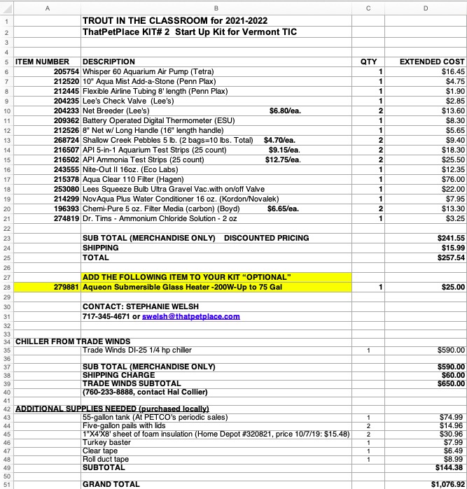

**Table 2 – Vermont TIC Replacement Supplies**

## 

## Appendix B Stages Of Rainbow Trout Growth

The following photos and discussion describe the stages of development of the rainbow trout. Of course, Vermont TIC schools raise brook trout. Until the juvenile stage of development, the brook trout and the rainbow trout will look very similar.

EGG

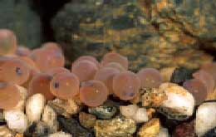

Trout eggs have black eyes and a central line that show healthy development. Egg hatching depends on the water temperature. It should be 50 to 55 degrees F (10 to 12.5 degrees C).

ALEVIN (pronounced AL-a-vin)

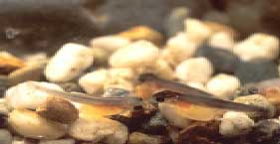

Once hatched, the trout have a large yolk sac used as a food source. Can you see it in this picture? Each alevin slowly begins to develop adult trout characteristics. An alevin lives close to the gravel until it’s ready to swim up, a stage also known as “buttoning-up.”

FRY

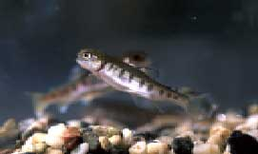

Buttoning-up occurs when alevin absorb the yolk sac and begin to feed on insects found in the water. Fry swim close to the water surface, allowing the swim bladder to fill with air and help the fry float through water.

FINGERLING AND PARR

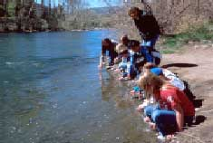

When a fry grows to 2 to 5 inches (5 to 13 cm), it becomes a fingerling. These trout are being released at this stage into Great Seneca Creek in Germantown. When a trout develops large dark markings, it then becomes a Parr.

JUVENILE

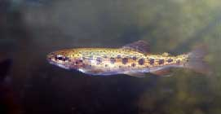

In the natural habitat, a trout avoids predators, including wading birds and larger fish, by hiding in underwater roots and brush. As a juvenile, a trout resembles an adult but is not yet old or large enough to have babies (or spawn).

**ADULT**

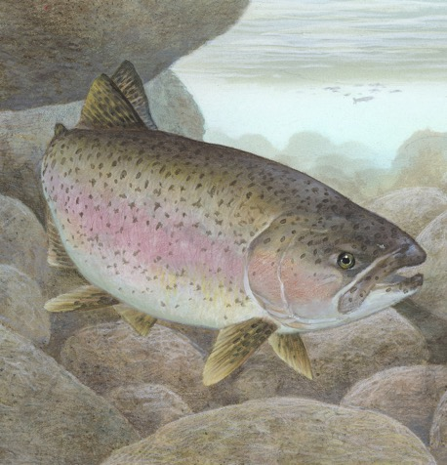

During the adult stage, female and male Rainbow Trout in the wild spawn in spring. Trout turn vibrant in color during spawning and then lay eggs in fish nests, or redds, in the gravel. When adult trout deposit their eggs, a new cycle of life begins.

## Appendix C Data Entry Spreadsheet

It is very important that TIC teachers and their students keep accurate records of tank conditions. The following screenshot is an image of the Excel spreadsheet that should be used in Vermont’s TIC program (and that can be found in the Google Docs collection on the VTTIC Web site). It’s not necessary to keep your data in an Excel document; some teachers prefer to use a Google Sheet format. Regardless of approach, however, recording all of these data elements accurately and in a format that can be submitted to the TIC Lead Facilitator at the end of the process is critical.

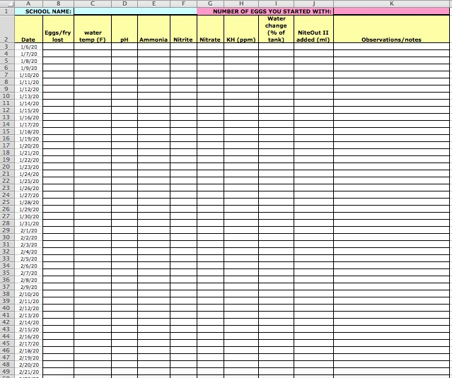

## Appendix D Instructions for Annual TIC Tank Set-up

**This Appendix supplements the instructions in Chapter 3 of this manual by providing a summary and photographs of the steps required for tank set-up and well as suggestions and hints for expediting this. Photography by Wayne Doc Leadbetter, MD**

1**. Clean Tank**

Tanks removed from storage should be rinsed and wiped out with a dilute bleach or vinegar solution. Rinse with fresh water and dry with paper towels. This helps remove contaminants or infective agents.

2. **Wash Gravel**

* Wash/rinse new gravel in a 5-gallon bucket using tap water. If this gravel was used the previous year it should have been cleaned in a dilute bleach solution when the system was placed in storage. Rinse it in tap water.
* Spread the gravel evenly on the tank bottom, but leave 1/4 of the bottom gravel-free to better see the accumulation of fish and food waste. Only about 1/2 inch of gravel is needed. The gravel provides about 20% of the tank’s bio-filtering.
* A rubber or plastic dust pan provides an easy way to remove gravel from the tank. Avoid dropping gravel onto the glass tank bottom when adding it.
* The photo also shows the placement of the chiller coil.

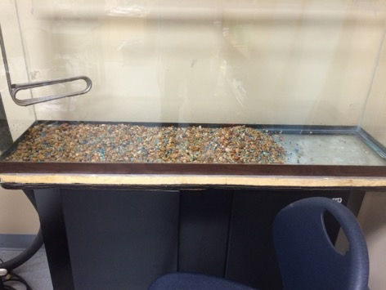

**3**. **Set up Stone Aerator.**

* Cut out old check valve from the tubing and replace it with a new one. A very light coating of Vaseline on the check valve and aerator fittings will make it easier to connect the tubing onto these components.

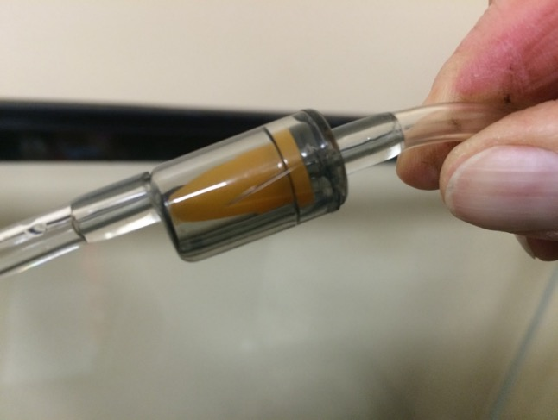

***NOTE: arrow on check valve points toward the air stone.***

* Trim and freshen tube end that attaches to aerator pump for better non-slip fit (i.e., eliminate the old expanded part)
* Bury the air stone in the gravel or use a zip-tie to attach it to a flat rock or piece of tile to keep it from floating up when the tank is filled. **Place it under the area where you intend to locate the chiller coil.** This will reduce the likelihood that your coil will ice up.

**4. Set up AquaClear 110** **filter**

### First-time Set-up

1. Assemble filter unit as shown in manufacturer’s diagram.

* Locate the foot, a plastic piece used to level the filter on the aquarium. (usually found in the filter cavity.)
* Attach foot to the filter using the hole in the bottom side of the filter.
* Attach a piece of fiberglass screen on bottom of inlet tube using cable tie.

1. Assemble filter cavity as follows: place foam block on bottom, position 10 ounces of rinsed Chemi-pure on top of the foam block and place rinsed BioMax on top of Chemi-pure.
2. Hang filter on aquarium back in opening of back insulation panel and level by rotating foot. Feed filter power cable through bottom of filter enclosure.
3. After aquarium is filled, scoop water into the filter cavity. Plug filter into electrical service. Make sure water is moving through it and falling back into the aquarium.

**Follow-on years setup**

1. Make sure the foam block and BioMax has been thoroughly cleaned with vinegar/water solution and rinsed well.

The foam block will require many cycles of soaking in cleaner and rinsing to remove all black material.

1. Assemble the filter with washed foam block on the bottom, position 10 ounces of rinsed new Chemi-pure in the middle and the cleaned bag of BioMax on top.
2. Check and clean the screen on the bottom of the intake tube. Replace if necessary.
3. Hang the filter on the back of the aquarium and level by rotating the foot.
4. Fill filter cavity with water and plug filter into electrical source. Make sure water is moving through the filter.

**5. Tank configuration**

For a new installation the top of the foam insulation will require cutouts for the filter and drop-in chiller coil. Generally, the filter is on the back left of the tank and the chiller coil on the back right. It may not be possible to maintain this configuration if the filter must be placed in front of or to the side of the tank.(“Flow-through” chillers, which we no longer recommend but are still widely used, require a different configuration.) If this is an existing system with previously cut and fitted foam insulation, you can easily determine where to locate the filter and the hose for the chiller coil. You should always install the aerator stone under the chiller coil to prevent icing. In many installations you can use the hose clamps to help hold the rear insulation in place.

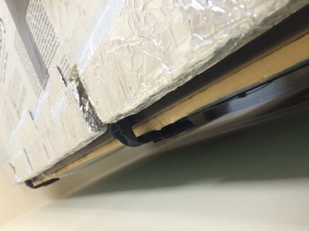

Foam top with cutouts for hose clamps

Chillers purchased after 2014 have a thermistor for temperature control that goes directly into the tank (always at opposite end from chiller coil). Older thermistors, such as the one shown in the photo, were not waterproof and had to be installed in a clear plastic tube and sealed with a black cork sealant. The plastic tube is held in place with a large suction cup.

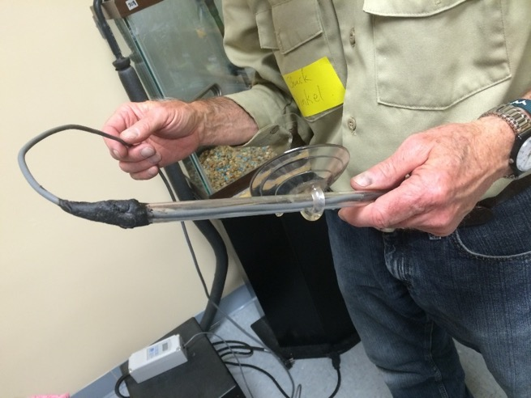

Place filter intake tube at the opposite end of the tank from the chiller coil and cover with mesh bag to protect alevin from being sucked into the filter. **N.B.: the mesh shown in this image is too coarse for brook trout fry.**

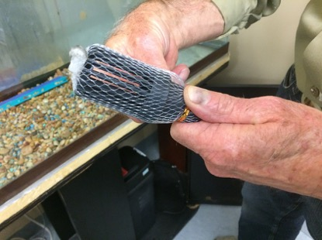

The smaller fry will get sucked into the filter. Instead, use mesh or nylon screening with 16 holes per inch (see photo below).



Attach the digital temperature gauge to the front of the tank fairly far away from the chiller coil. If this is a new gauge the battery cover has to be first opened to remove the plastic that prevents the battery from making contact and discharging. It is always good practice to remove the battery at the end of the year and store it and the gauge in a zip lock bag. If the suction cup that attaches the gauge to the tank is lost use double-faced Velcro to attach it.

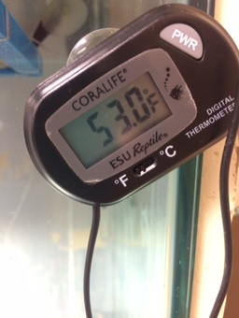

**6. Chiller**

* Clean intake (metal) grill with stiff paint or tooth brush to remove dirt and dust (check every 2 months). Be careful to avoid cutting yourself on the sharp metal fins. If dirt builds up, the compressor will overheat due to lack of air circulation, and the chiller will be damaged and may stop working.

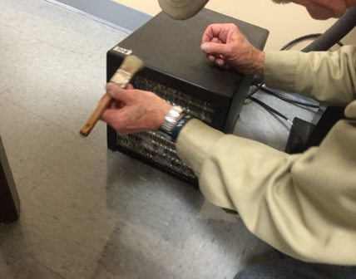

* Plug chiller power cord (This is a male plug and on a new unit this is located on the outflow side of the unit) into the female plug on the control unit. The male plug on the control unit will later be plugged into the power strip***. NEVER operate the chiller unless the coil is completely covered by water!***
* When you are ready to run the chiller, plug it into the power strip and following the instructions provided with the control unit set it for it for degrees F; tank temperature 52-54 degrees; differential of 2 degrees; and for cooling (C1). When you complete this procedure the unit should begin running as long as the temperature showing on the controller display (tank temperature) is at least 2 degrees warmer than the52-54 degree setting you entered.
* Keep the controller unit out of sight of students. There is always a temptation to “play” with devices such as this. Changing any of the settings can lead to catastrophic loss of fish. It is also a good idea to protect the unit from moisture by placing it in a zip lock bag; then only the wires are exposed.
* If your chiller stops working you can sometimes correct a problem by turning it off for about five minutes and turning it back on. You can also try going through the start-up sequence for the control unit. TIC volunteers may have a spare chiller. Notify us immediately of a problem and put the frozen bottles of water in the tank to help maintain the correct temperature.

**Control unit for chiller**

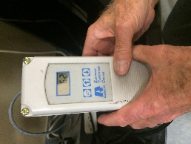

**7.Fill Tank**

**Fill tank before plugging in chiller or filter.**

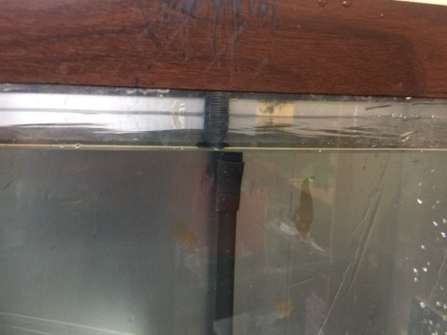

Tap water can be used, *but* ***all water placed in the tank, including the first fill, must be treated with NovAquaPlus water conditioner,*** which removes chlorine and heavy metals.

**This modification makes it easier for students to clean the tank:**

To allow the siphon cleaning tube to reach the bottom of the tank without having to get your hands into 52 degree temperature water attach a 24”—36” section of flat molding, dowel, or yardstick to the plastic tube as shown. For most tanks a 26” extension is sufficient. If your tank is deeper, use a longer length. Use zip ties that are at least 11” in length to secure the molding. This technique also makes it a lot easier for students to maneuver the siphon tube when cleaning the tank bottom and gravel.

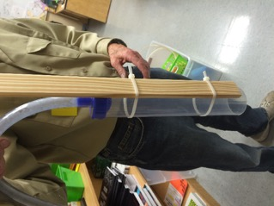

### Appendix E Directions for Solutions Added to TIC Tanks

**Instructions below are for 55-gallon tanks. If tank size is different, adjust amounts accordingly.**

**Instructions for Nite-Out II**

Nite-Out II’s highly specialized microbial consortium of nitrifying cultures is specially formulated to eliminate ammonia via a natural biological process termed nitrification. The cultures in Nite-Out II will establish, promote, or stabilize and maintain nitrification in aquarium waters, eliminating the toxic effect of ammonia. Nite-Out II liquid nitrifying bacteria contains select strains of Nitrosomonas, Nitrospira, and Nitrobacter. Nitrosomonas oxidize ammonia to nitrite and Nitrobacter and Nitrospira oxidize nitrite to nitrate. Nite-Out II comprises select microorganisms that are autotrophic—able to use carbon dioxide as the sole source of carbon—and are relatively slow growing, requiring specific conditions for optimum growth, with typical cell divisions rates from 12 to 24 hours. Their performance and rate of growth are impacted by the environmental parameters required for nitrification.

Shake well before using. Add directly to the tank and filter.

For the first 4 weeks, add 25 ml of Nite-Out II every Monday, Wednesday, and Friday.

Beginning week 5, clean half the gravel one day and replace water removed with de-chlorinated water. Add 20 ml Nite-Out II. Clean the other half of the tank later in the week. Replace water removed during cleaning. Again add 20 ml Nite-Out II. Continue until all product is used. If you use a different water change schedule make sure you add 20 ml of Nite-Out II twice during the week. Note that the amount of water you change will increase as the fish grow in size. If ammonia levels begin to increase to unacceptable levels, increase the amount of Nite-Out II added to your tank. The bacteria in your tank should provide the first line of defense against changes in your tank that affect water chemistry balance. Water changes are secondary to biological activity. Allowing the bacteria to do their job will reduce your need for water changes.

NOTE: Shelf life is 18 months unopened; 12 months if opened. DON'T FREEZE, REFRIGERATE. Avoid sunlight. The date of manufacture is printed in black ink near the bottom of the bottle. The first 2 numeric characters signify the year; the alphabetical character is the month. For example: in the case of (15K 04-1), the year is 2015; since K is the 11th letter of the alphabet, the month is November. Ignore other characters.

**NovAqua Plus (tap water conditioner) directions:**

***ALL* Tap Water *MUST* be treated before adding to tank**

NovAqua Plus detoxifies chlorine and chloramines and removes copper and harmful metals.

Use 1 teaspoon (approx. 5 ml) for each 10 gallons of water (1 ml treats 2 gallons). A standard eye dropper holds about 1 ml of liquid. You can also use a medical syringe or the measuring cap from another solution **IF** you wash it out before using it for another liquid. Add a gallon of tap water to your “clean water” 5-gallon bucket Add appropriate amount of NovAqua Plus for the **total** amount of water you plan to treat. Mix and then add remaining tap water.

Don’t mix up more than 3 gallons in a 5-gallon bucket even if you need more than that amount. Fill the bucket twice to avoid spillage. Use a gallon milk jug with the top removed to dip water from the bucket and add it gently to the tank.

**Sodium Bicarbonate (baking soda) directions:**

Use test kit to measure KH weekly. Desired reading is at least 150 ppm when the tank is initially set-up and at least 100 ppm after the first 4 weeks. One teaspoon per 55 gallons raises Carbonate Alkalinity (KH) by about 17.9 ppm. Dissolve baking soda in beaker of tank or de-chlorinated water before adding to tank.

Store in zip lock bag to prevent caking. Baking soda has a pH of 8.4.

**IT IS RECOMMENDED THAT YOU COPY AND LAMINATE THE FOLLOWING TABLE, WHICH PROVIDES A SUMMARY OF THE SOLUTIONS TO BE ADDED TO THE TANK WATER AND THE AMOUNTS REQUIRED.**

**Table for Adding Solutions to Tanks**

|  |  |  |
| --- | --- | --- |
| Nite-Out II | 20 ml 2 times per week during gravel cleaning |  |
|  |  |  |
| NovAqua Plus | **First fill of tank** | **Afterwards** |
|  | 5 ml (1tsp.) per 10 gallons of water | 1 ml per 2 gallons of water added |
|  |  |  |
| Baking Soda | **KH = 150 ppm at tank set-up** | **Min. level after week 4,**  **KH = 100 ppm** |
|  | 1 tsp./55 gal. =  KH increase of 17.9 ppm | 1 tsp./55 gal. =  KH increase of 17.9 ppm |

### Appendix F Modifying the Breeder Basket

The breeder basket sold with the ThatPetPlace kit uses netting that is so fine that, rather than allowing waste to pass through the netting, it traps all food and fish waste. This can create a very unsanitary medium at the bottom of the net bag, potentially a breeding ground for infection. As a result, we advise that you replace the bottom netting panel with coarser nylon screening using the methodology detailed below.

WHAT YOU NEED:

1. Net breeder basket
2. Aquarium cement
3. Scissors
4. Fiberglass screening 4½” x 6½”
5. Saran wrap
6. Aluminum wire 18 gauge
7. Wire cutter

PROCESS:

1. Assemble basket frame
2. Place large piece of saran wrap on bottom outside of frame (to protect it from the cement)
3. Place net on frame so the wrong (unfinished) side of the net is on the outside. Pull loop on net tight so net stretches over frame.
4. Sit assembly upside down. Bottom should be pointing up.
5. Squeeze a small amount of cement continuous bead around edges of bottom
6. Place piece of screening on the cemented area
7. Lay another piece of saran wrap on top of screen
8. Turn complete assembly over on hard flat surface and press on top so cement flattens out.
9. Let sit for 24 hours.
10. Remove net from frame and take off both sheets of saran wrap.
11. Let net sit another 24 hours.
12. Cut original (small opening) net flap piece away from bottom of screening.
13. Place modified net on the inside of the frame so the right (finished) side is where the eggs will eventually be placed.
14. To stabilize the net in the frame, wire the 4 bottom corners of the net to the frame using the aluminum wire. Fold top of net down over frame top. Tighten and knot drawstring.

New screening glued over bottom netting.

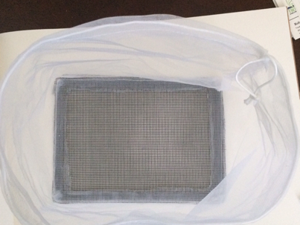

Screening after fine netting has been cut away and net bag has been turned inside-out.

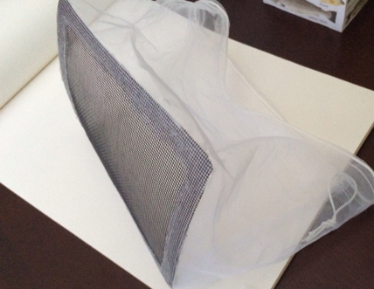

The instructions that come with the breeder (egg) basket call for the net to go on the outside of the frame. Note that in the photo the net is inside the frame. This is the preferred method as it prevents the small alevin from getting trapped in crevices in the frame. Use a needle and thread or fine wire to attach the four corners of the net to the corresponding corners of the frame. Basket placement: Place the breeder basket out of the direct outflow of the filter. Some water circulation is OK as long as the eggs do not get pushed into a corner of the basket by the flow.

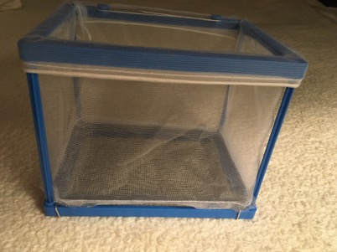

Modified bag installed inside plastic frame. Voila!

**Appendix G First Feed**

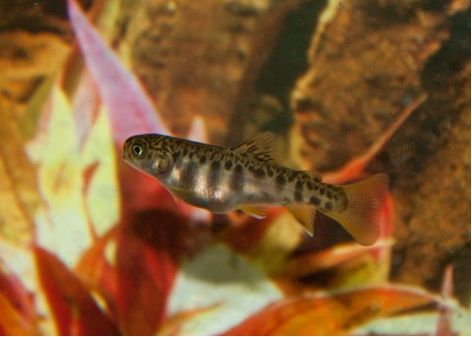 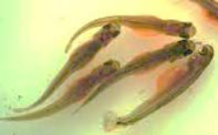

**Image 1. Round belly: Too early. Yolk material remaining (seam appearance)**

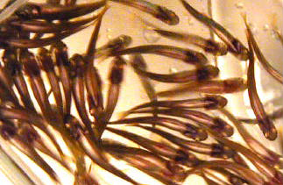  **I** = No! I = Yes (width of slit)

**Image 2. >50% w/only a small “seam” = FEED ME!**

**When Do I Feed?**

Timing of “first-feed” is critical in young trout. Initially, fry will “swim up” to inflate their air bladders - - independent of the need for food (Image 1). Important to delay first-feed until vast majority of fish (>50%) have only a small slit of yolk visible; research indicates that fish still have considerable yolk reserves when only a slit is present. Feeding too early is not advantageous to the fish and only creates a fouled tank environment. If you are in doubt, place a small number of fry in a clear glass beaker/jar to examine the ventral surface (belly) from below (Image 2).

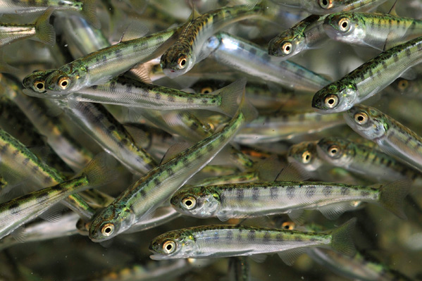

**Slender, small slit of yolk present—perfect!**

### YouTube video

### To help teachers identify the swim-up stage and the right point at which to begin feeding your fish, the Pennsylvania Fish and Boat Commission has provided a short video.

### Here’s its URL: https://www.youtube.com/watch?v=0VfuBYoeb8g

### Appendix H Predicting/Determining When Swim-up Occurs

It is extremely important to notice when alevin are ready to eat for the first time. One way to tell when your fish reach this stage is through visual observation, as is discussed in the previous appendix. You can also use a measure called Development Index (DI) to estimate when the fish are at the “swim-up” stage.

DI is based on temperature. Each day the water temperature is above 32**°,** a particular constant is added to whatever the previous day’s DI total was. The table below shows what these constants are for each temperature value between 32**°** and 56**°**.

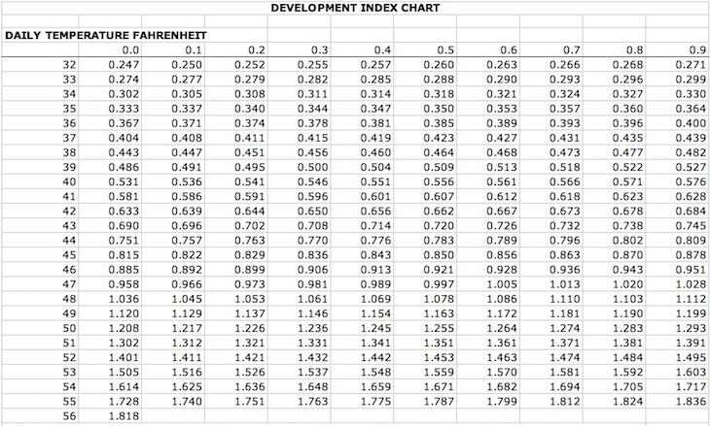

Teachers can use DI in two ways: to **predict** when swim-up is likely to occur and to **determine** when swim-up occurs.

**To predict when the swim-up process is likely to start**

1. In the Google Docs folder you’ll find an Excel file called “2021 Temp and DI record and swim-up calculator.”
2. Open this file and read and follow the “Instructions” for Method 1.
3. When your eggs are delivered, the person making the delivery should be able to tell you what the DI is as of that date. This number should be entered into the cell in Column D, “CUMULATIVE DI TO DATE,” that corresponds with the date when you receive your eggs.
4. On the day after your eggs were delivered, enter the tank’s temperature in Column B, “TEMP F,” in the row corresponding to the date.
5. Then continue to enter temperature data for **every** day, including weekends and school holidays. No one expects you to go to school on the weekends to check the temperature. Simply **estimate** what it was. For example, if the tank was 46**°** when you left on Friday and is 44**°** when you come in on Monday, assume that the tank was at 45**°** both weekend days.
6. Once the Cumulative Di reaches 85, remove the top and front covering during the day to expose the alevin to light.
7. Now’s the time to start paying close attention. Based on 2016-2017 data, we can expect approximately half the alevin to be swimming up when the DI is between 85 and 93.

**To determine when you want the swim-up process to start**

We have found that, at the tank water temperatures Vermont teachers typically use, swim-up sometimes occurs in early March, when many schools have a weeklong break. This is both inconvenient and highly risky, as it is a time when the teacher is either away from school altogether or when she/he would find it extremely difficult to monitor the tank and its alevin. Because of this, quite a few schools have “missed the swim-up” in the past.

In order to avoid this very consequential mistake, the same file we discussed above (“2021 Temp and DI record and swim-up calculator”) includes a worksheet (Worksheet “C. Swim-up calculator”) that allows you to determine the temperature at which you should set your chiller in order to have swim-up occur approximately when you want it to.

**N.B.: The formula in the calculator assumes that 50% of your alevin will swim up when they reach a DI of 85. As mentioned above, the data we got from schools last year indicate that that rate of swim-up (50%) can occur as early as a DI of 85 but also as late as a DI of 93. So don’t panic if half of your fish haven’t swum up on the date the calculator indicated they might. On the next page you’ll find a chart of 2017 swim-up data from eight Vermont schools.**

**DIs at which different rates of alevin were swimming up**

**Spring 2017**

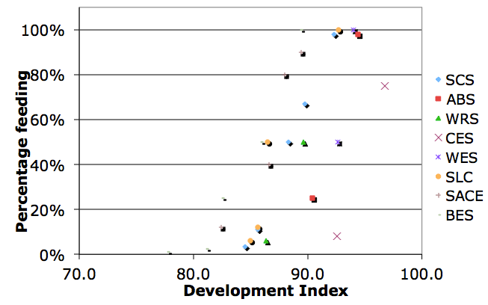

### Appendix I COVID-19 Special Instructions

On March 13, 2020, education in Vermont was “all shook up.” On that date, Governor Phil Scott ordered schools closed. With almost no warning, teachers and students headed for home and did their best to continue teaching and learning in spite of the profound disruption brought about by having to abruptly transition to an all-online approach.

Over the next hours, days, weeks, and months, TIC teachers had to make decisions about their trout and tanks. A few released their fish that last day in school and emptied their tanks. Others were allowed to continue to enter the otherwise closed school so that they could service the tank and keep their trout alive. Some moved their tanks home and raised the trout in the basement, garage, or study. Still others got tremendous support from school staff—custodians, kitchen personnel, secretaries, and principals—who volunteered to take on tank maintenance responsibilities. In the end, all schools released their trout into the wild, some in March, some as late as early June.

Paradoxically, overall, the Vermont TIC program may have had one of its highest survival rates in spite of those trying times. Go figure!

**TIC in 2020-2021**

Impressively, half of the schools that participated in the TIC program during the highly disrupted 2019-2020 TIC year chose to continue the program in 2020-2021. That meant that we had more than 49 stalwart teachers and others returning to TIC in spite of the uncertainty that hung over that school year. In addition, staff at Norwich Vermont’s, Montshire Museum and Burlington’s ECHO Center agreed to set up and let teachers and their students observe trout tanks in the TIC fashion. While the pandemic forced us to dispense with the usual fall training workshop, we tried to fill that gap with a series of online Zoom workshops. Surprisingly, some experienced TIC teachers had their greatest success last year. Go figure!

**TIC in 2021-2022**

As this Manual is being revised in August 2021, we cannot predict what schools will look like in January 2022. The hope is that Vermont’s highest-in-the-world vaccination rate—as of this writing, 85.9% of eligible Vermonters have received at least one dose—will allow a “return to normalcy” for Vermont schools. Of course, vaccination rates vary by region of the state, by town, and by school.[7]

If conditions on the ground worsen, we may have to make changes to our normal approach. One thing that’s clear is that teachers will in one way or another—or perhaps in more than one way—be educating Vermont’s children throughout 2021-2022. What’s also clear is that Trout in the Classroom is an engaging and, for some, a *transformative* educational experience. So we will continue to support TIC and hope that many teachers will pursue it this year not only *in spite* of the unusual circumstances, but perhaps *because* of them. More than ever, our children need to be connected to *real* things.

The purpose of what follows is to address some of the special issues and questions that we, as Vermont’s TIC community, will be facing this year.

**When do you have to decide whether to do TIC?**

The short answer is whenever you’re comfortable making a decision. If you can let us know fairly soon, it will allow us to inform the Vermont Fish and Wildlife Department and its Roxbury hatchery staff approximately how many eggs we’ll be needing for schools. But as long as you’ve order the equipment and supplies you’ll need, you could make the decision to participate as late as December 1.

As in all recent years, the plan is to deliver eggs to schools in early January, probably in the first or second weeks of January. As long as teachers can get their tanks set up and equipment tested at least a week before the arrival of the eggs, they should be able to initiate the program.

We highly recommend that teachers participate in the pre-cycling program that we began last year. That would require that they set up their tanks on or before Thanksgiving weekend, but you can join the program even without going through the pre-cycling process.

Either way, teachers choosing to enroll in the TIC program this year will need to let Joe Mark, Lead Facilitator, VTTIC, know no later than December 1, 2020.

### Where should you locate your tank?

With Vermont’s high vaccination rates, we assume that you should install your tank at the school. In “the old days,” tanks were always in the classroom of the lead TIC teacher (or, if there wasn’t sufficient room there, occasionally in a hallway near the TIC teacher’s classroom or in the school library). In spring 2020, when schools were abruptly closed, we allowed teachers to take their tanks home or transfer them to a colleague’s house. While it seems quite unlikely that Vermont schools will go “all virtual” this year, it would again be an option to move the tank out of the school.

Moving the tank once it’s full of water and fish isn’t easy, but it can be done. I or your local TIC volunteer can offer suggestions on the process.

**Assuming you set up your tank at school, …**

1. **Be ready to “tent” your tank**

Given what we’ve learned about the aerosol transmission of SARS-CoV-2, I suspect that schools won’t be as aggressive about cleaning practices this year. But if your school plans to frequently sanitize classrooms, it will be important to speak with your custodian/maintenance director about the school’s sanitizing plans. Tell them how sensitive salmonids are to toxic cleaning substances. *Plead* with them to notify you in advance of any cleaning/spraying activities. Explain that you will need to “tent” your tank to protect your fish from whatever cleaning supplies will be used. If at all possible, ask them to keep spraying as far away as possible from your tank.

To “tent” your tank:

* Tent the tank with a plastic drop cloth.
* Make sure air pump, chiller, and other fan intakes are in a covered space.
* Put “Do not spray” sign on tent.

**B. Try to influence the cleaning solutions they use.**

When you speak with your custodian/maintenance director, try to influence their choice of cleaning solution. If they’re open to your input, here’s a suggestion:

Request that your school use a spray of Hypochlorous acid (HOC).

Hypochlorous Acid  (HOCl)

What makes HOCl 100x more effective than bleach against viruses, bacteria, and fungi is that it has both a neutral pH and no electrical charge.

* Germ surfaces carry a negative electrical charge which results in a repulsion of negatively charged disinfectants, such as bleach and ammonia.
* HOCl is neutral (has no charge) and therefore adheres to the negative surface of the bacteria, fungi, and virus and kills very quickly.
* HOCl is found on the EPA’s “LIST N: Disinfectants for Use Against SARS-CoV-2 (COVID-19)”

While Chemical sanitizers, when available, do affect the time needed to eliminate the COVID-19, HOCl  has been reported up to 300 times more effective than chemical sanitizers. The main reason for this is HOCl’s stability and on an elevated electrical charge or “super active energy” that destroys the microorganisms very quickly. This high electric potential dissolves the guarding lipid, coating the capsulated viruses and destroying them. It is a fact that viruses never form a resilient variant to HOCl and the risk of resistant super-germ, is considerably reduced.

It is important to note that HOCl is safe to manage and stock, and non-hazard to people and pets. HOCl formulation contains the equivalent chemistry that the natural defense system of human bodies applies to defend itself from attacking pathogens. Hypochlorous Acid (HOCl) is a greatly influential disinfectant that is around neutral PH, which secures it quite safe when in contact with people, but harmful for evading pathogens of any kind.

Per the Centre for Disease Control and Prevention (CDC), the following properties are considered ideal for a disinfectant:

* Broad-spectrum efficacy - A good disinfectant should have the capability of targeting a wide variety of organisms, i.e. bacterial, viral, and fungi microorganisms. It should also have a high efficacy in its action as an antimicrobial.
* Non-inflammable - This property enables disinfectants to be used over large areas with no health or safety concern including use in areas with flammable products such as kitchen and laboratories.
* Fast drying with short contact time – This property is essential to decrease the duration of bio-decontamination. A fast-acting agent quickly destroys microbes hence reducing the duration of potential contact with the microbes.
* Non-toxic - The disinfectant should not harm the user and cause any discomfort. It should be user-friendly.
* Surface Compatibility - The disinfectant should have the capability to be used on most surfaces and instruments without corroding them or damaging their structural integrity.
* Ease of use - An ideal disinfectant should be easy to use, store and discard, with clearly labeled instructions.
* Odorless - Ideal disinfectants should be odorless or with a pleasant smell to facilitate regular use.
* Alcohol Free - Alcohol based Hand Sanitizers are contributing to many types of bacteria becoming alcohol resistant.
* Environmental friendly - An ideal disinfectant should have the capability of being used in the environment without causing any harm to the users and the environment.

In addition to the ideal properties, the product should also be cost-effective and easily accessible. Hypochlorous acid (HOCl) fits into the CDC requirements for an ideal disinfectant as it has broad-spectrum efficacy, is odorless, non-flammable, non-toxic, fast drying, environmentally friendly and is easy to use.

**Curriculum Suggestions**

**Trout Cam**

If you think there’s any chance that you and your students might have to “go remote” at any point during the year, you might want to set up a “trout cam.”

One of our Trout in the Classroom teachers, Diane Corrigan, let our national TIC/SIC list serve know that she’s been using a live “Trout Cam” to allow her students to follow the development of their fish even when they’re participating in “virtual schooling.” Here’s a link to the live feed coming from Diane’s camera: <https://www.myearthcam.com/troutteacher>. As you can see, Diane’s feed is hosted by EarthCam, a free service. I also asked Diane which camera she uses. Here’s a link to the product she bought that is available on Amazon (for $23.99): <https://www.amazon.com/dp/B016K4B41I/ref=cm_sw_r_cp_api_i_mUXfFbPKGGMJ6>. It is not submersible, but Diane told me that she cut a hole in the screen top and used pipe cleaners to attach it to the lid. Ingenious!

**Virtual Trout in the Classroom in Idaho**

Here’s <https://localnews8.com/news/2020/05/19/trout-in-the-virtual-classroom-when-hands-on-learning-goes-digital/> a report on what folks in Idaho did when COVID-19 drove the TIC programs from the schools. A collaboration between Idaho Fish and Game and the Idaho Museum of Natural History resulted in the production of several TIC-related YouTube videos, including one on trout dissection. Stumbling onto that collaboration also allowed me to find the museum’s collection of other resources, including some neat activities that students can do at home. Here’s that URL: <https://www.isu.edu/imnh/imnh-education-outreach/trout-in-the-classroom/>. That page includes a lesson on using a plastic bottle and plastic lids to test how fins of different sizes and shapes help the fish to move through water. Great stuff!

**Trout videos**

Other the years I’ve assembled *twenty-two* mostly YouTube videos that seemed relevant to TIC. They can be found on the Other Trout Videos” page of the VTTIC web site. Here’s the URL for it: <https://www.vttucouncil.org/?page_id=343>. I think you and your students will enjoy them. Here’s some of what you can find there:

* The life cycle of a trout
* “Redd” building and counting
* The process of spawning at a hatchery
* The *Artifishal* documentary
* Trout population sampling
* The “chop and drop” method for improving trout habitat
* Stream habitat improvement work in Maine
* The problem of inadequate culverts
* Macroinvertebrates
* Dissecting trout
* Etc.

But don’t stop here. These are just a few of the videos I was able to find, and that was a while ago. Every week more are being posted.

**National Trout Unlimited TIC Resources**

And don’t forget that over the years, current TIC national coordinator Tara Granke and those who proceeded her in that role have collected numerous TIC curriculum ideas in this web page: <http://www.troutintheclassroom.org/teachers/lesson-plans>.

Check it out! I think you’ll be pleased by what you find there.

### Appendix J VTTIC Contact Information

Here are the names of and contact information for the individuals most active as TIC volunteers. They’re grouped by geographic regions that coincide with Vermont’s five Trout Unlimited chapters.

Central Vermont Chapter of TU (Addison, Chittenden, Franklin, and Grand Isle counties)

Ed Collins, CVTU TIC Liaison, coll158@comcast.net

Chuck Goller, maxvert@comcast.net

Bob Wible, rwible1@msn.com

Connecticut River Valley Chapter of TU (Windham and southern Windsor county)

Paul Gudewicz, CRVTU TIC Liaison, p.gudewicz123@gmail.com

Greater Upper Valley Chapter of TU (Orange and northern Windsor counties)

Ron Kovanic, GUVTU TIC Liaison, rkovanic6@gmail.com

Robb Cramer, rcramerjr@icloud.com

Dan “Rudi” Ruddell, Monitoring & Education Coordinator, White River Partnership, rudi@whiteriverpartnership.org

Mad Dog Chapter of TU (Caledonia, Essex, Lamoille, Orleans, and Washington counties)

Clark Amadon, MDTU TIC Liaison, clarkamadon@gmavt.net

Jeremy Whalen, Supervisor, Roxbury Fish Culture Station, jeremy.whalen@vermont.gov

Southwestern Vermont Chapter of TU (Bennington and Rutland counties)

Joe Mark, Lead Facilitator, VTTIC, and SVTU TIC Liaison, joe.mark@castleton.edu

Chris Alexopoulos, calexopoulos@fs.fed.us

Gordon Batcheller, gordon.batcheller@gmail.com

Barry Mayer, flyh2o@comcast.net

Trip Westcott, jivetw@hotmail.com

1. This edition includes additions, deletions, and modifications designed to customize the Manual for the practices recommended in Vermont’s TIC program. We enthusiastically thank Chuck Dinkel and others who for years have been associated with the development of the MD/DC manual for allowing us to “tweak” their fine document so that it better supports our local work.
2. In many ways, VTTIC can be seen as an evolution of the state’s Salmon in the Classroom program—also known as Adopt a Salmon—that could be found in scores of Vermont schools, especially in the Connecticut River watershed, from the early 1990s into the first decade of the 2000s. SIC, at the time sponsored by the US Fish and Wildlife Service, was discontinued in 2011 when two developments converged: Tropical Storm Irene destroyed the federal fish hatchery in Bethel, where salmon had been raised, and research revealed that the years-long efforts to reintroduce salmon to the Connecticut River had been largely unsuccessful.
3. A handful of schools located near streams that experience runs of landlocked Atlantic salmon can be eligible for salmon eggs instead of brook trout eggs.
4. If you place the tank on a counter that has cabinets above it, make sure there’s enough room between the top of the tank and the bottom of the cabinets to allow you to service the tank.
5. We believe these mixed results were because (a) the instructions were misunderstood or not carefully followed and/or (b) the water in some classrooms was too cold. We have clarified the instructions that follow, and this year we recommend that teachers acquire and use a tank heater during the pre-cycling period.
6. Ammonia and nitrite levels of 5 ppm would be **highly toxic** if there were fish in the tank.
7. This morning’s *Rutland Herald* carried a quote from our local superintendent indicating that only 20% of the students at Fair Haven Union High School had been vaccinated.